**Supplementary Information**

FTIR, XRD, EDXRF, and SEM-EDS results presented below are of the sediment materials collected around of the fossil.

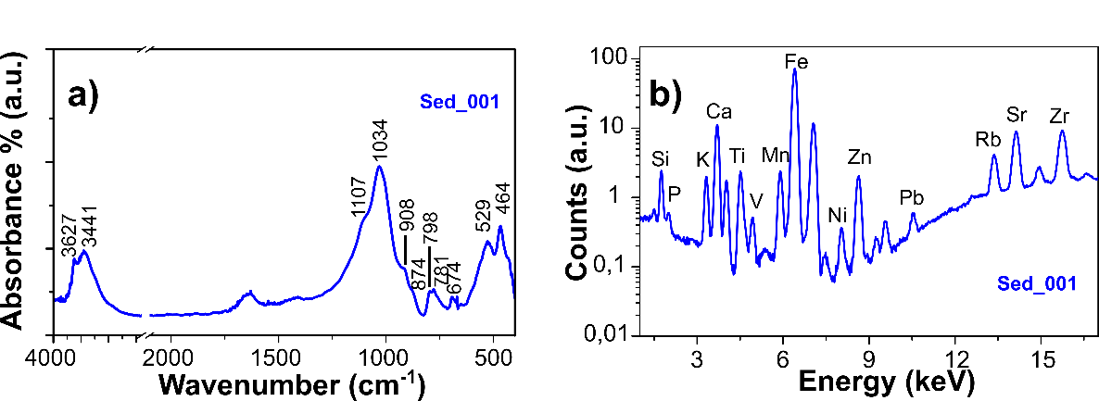

Sup. 1 a) Vibrational response and b) elemental composition of the sedimentary material Sed_001 from sample FACEN-Pvert0002.

|  |  |  |
| --- | --- | --- |
|  | **FTIR response Sed_001** |  |
| **Wavenumber (cm-1)** | **Assignation** | **References** |
| 464 | Si-O-Si asymmetrical bending  Allophane | (1,2) |
| 529 | Si-O-Al stretching | (3,4) |
| 674 | Si-O symmetrical bending  Si-O-Al stretching | (3,4) |
| 781 | Si-O symmetrical stretching | (2–4) |
| 798 | Si-O symmetrical stretching | (2–5) |
| 874 | CO3 | (6–8) |
| 908 | Al-(OH) | (4,9) |
| 1031 | Al(OH)3  Si-O-Si | (2,10,11) |
| 1107 | Si–O–Si or CO3 | (2,3,5,7) |
| 3441 | -OH | (4,9,12,13) |
| 3627 | -OH | (4,9,12,13) |

Sup. 2: Table of vibrational responses of the sedimentary material Sed_001 from sample FACEN-Pvert0002.

Sup. 3: X-ray diffraction pattern of sedimentary material Sed_001 from sample FACEN-Pvert0002, indicating the identified crystalline phases.

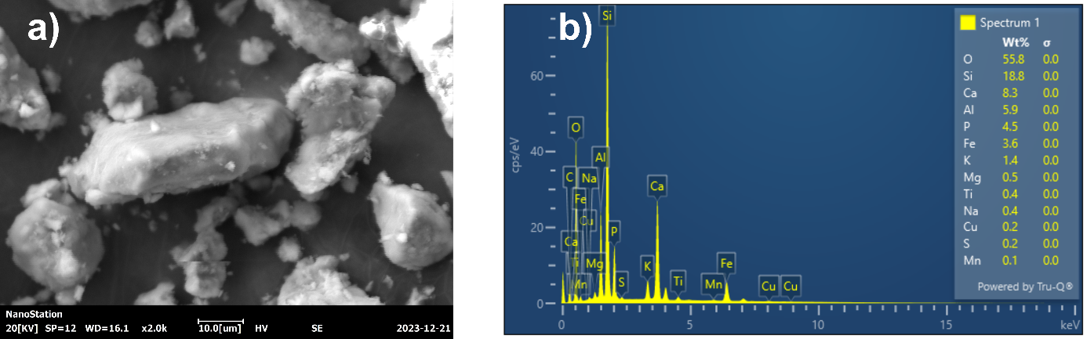

Sup. 4 SEM- EDS image of Sed_001

References

1. Hlavay J, Jonas K, Elek S, Inczedy J. Characterization of the particle size and the crystallinity of certain minerals by infrared spectrophotometry and other instrumental methods—I. Investigations on clay minerals. Clays Clay Miner. 1977;25:451–6.

2. Singh P, Sharma S. Thermal and spectroscopic characterization of archeological pottery from Ambari, Assam. J Archaeol Sci Reports. 2016;5:557–63.

3. Anbalagan G, Prabakaran AR, Gunasekaran S. Spectroscopic characterization of indian standard sand. J Appl Spectrosc [Internet]. 2010 Mar 25 [cited 2021 Jun 16];77(1):86–94. Available from: https://link.springer.com/article/10.1007/s10812-010-9297-5

4. Nayak PS, Singh BK. Instrumental characterization of clay by XRF, XRD and FTIR. Bull Mater Sci. 2007;30(3):235–8.

5. Khemis Medini H, Arbi M. Chemical and physical analysis of sandstone and relationship with weathering damage of Madâin Sâlih monuments. 2018 [cited 2021 Jun 16]; Available from: https://www.tandfonline.com/action/journalInformation?journalCode=tusc20

6. Beasley MM, Bartelink EJ, Taylor L, Miller RM. Comparison of transmission FTIR, ATR, and DRIFT spectra: implications for assessment of bone bioapatite diagenesis. J Archaeol Sci. 2014;46:16–22.

7. Jerez-Jaimes JH, García-Gómez SE, Cruz-Guevara LE. ¿Hueso fósil o simple roca? Espectroscopia FTIR y criterios para la identificación de estructuras óseas fosilizadas. Bol Geol. 2012;34(1):67–80.

8. Brangule A, Gross KA. Importance of FTIR spectra deconvolution for the analysis of amorphous calcium phosphates. In: IOP Conference Series: Materials Science and Engineering. IOP Publishing; 2015. p. 12027.

9. Zhang J, Xiao J, Li S, Ran W. Manure amendment increases the content of nanomineral allophane in an acid arable soil. Sci Rep [Internet]. 2017 Dec 1 [cited 2021 Jun 16];7(1):1–8. Available from: www.nature.com/scientificreports/

10. Iyoda F, Hayashi S, Arakawa S, John B, Okamoto M, Hayashi H, et al. Synthesis and adsorption characteristics of hollow spherical allophane nano-particles. Appl Clay Sci. 2012;56:77–83.

11. Schuttlefield JD, Cox D, Grassian VH. An investigation of water uptake on clays minerals using ATR‐FTIR spectroscopy coupled with quartz crystal microbalance measurements. J Geophys Res Atmos. 2007;112(D21).

12. Wan T, Wang X, Yuan Y, He W. Preparation of a kaolinite-poly(acrylic acid acrylamide) water superabsorbent by photopolymerization. J Appl Polym Sci [Internet]. 2006 Nov 5 [cited 2021 Jun 16];102(3):2875–81. Available from: www.interscience.wiley.com

13. Reig FB, Adelantado JVG, Moreno MCMM. FTIR quantitative analysis of calcium carbonate (calcite) and silica (quartz) mixtures using the constant ratio method. Application to geological samples. Talanta. 2002;58(4):811–21.