Supplementary material of

Jaguar at the edge: Movement patterns in human-altered landscapes.

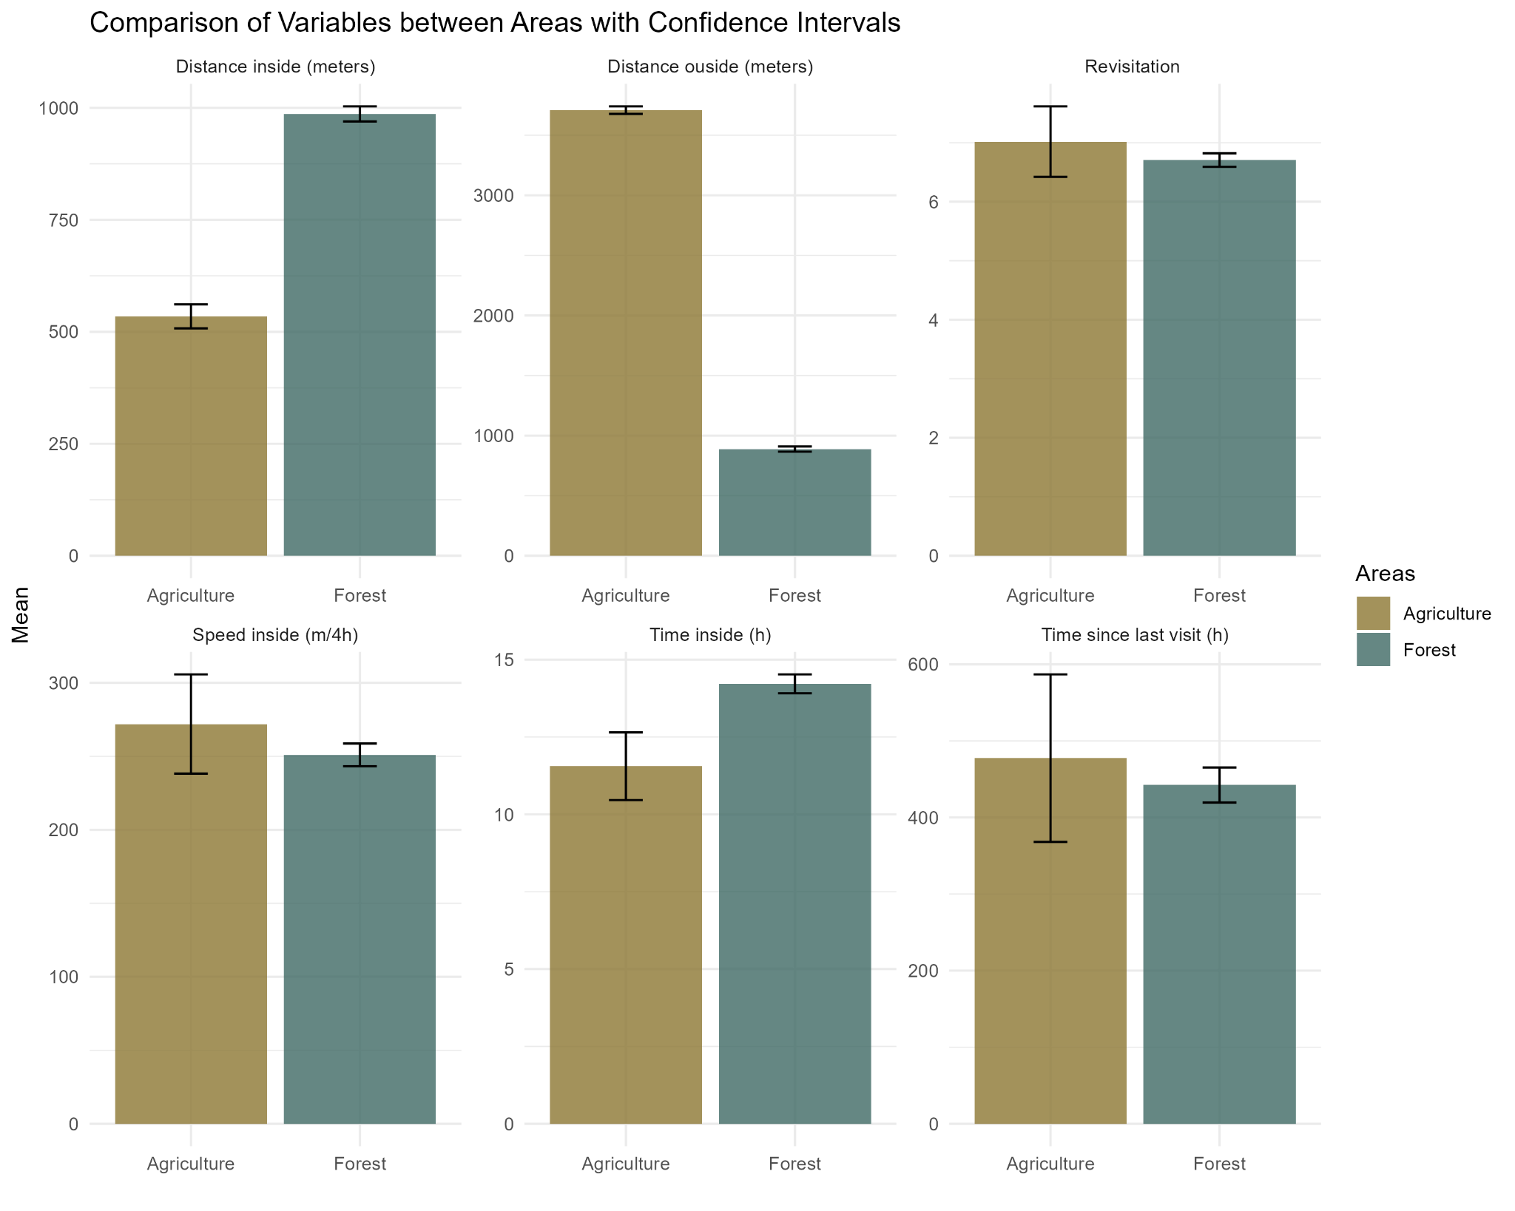

**Figure A:** Comparison of various environmental variables between agriculture and forest with 95% Confidence Intervals. The bars represent the mean values of each variable, and the error bars indicate the 95% confidence intervals around these means.

**Figure B.** Mean time in hours inside the forest and agricultural patches by size groups of their respective classes. n= number of locations

**Figure C:** The number of visits across different distances of four land cover variables. Negative values indicate the distance within the variable, 0 is the edge, and positive values indicate the distance outside the variables.

**Table A.** GPS data of the jaguar individuals used for this study. The study area number, ID, and planned schedule of the GPS tracking collar were expected according to the information from the source database (Morato et al. 2018); the planned schedule is observed according to our analysis and cleaning of the data. The mean distance between scheduled successive locations (DIST. MEAN) and mean distance of resampled 4-hour (DIST MEAN 4HRS), were used in this study.

|  |  |  |  |  |  |  |  |  |
| --- | --- | --- | --- | --- | --- | --- | --- | --- |
| **STUDY AREA** | **ID** | **SEX** | **COUNTRY** | **PLANNED SCHEDULE EXPECTED** | **PLANNED SCHEDULE OBSERVED** | **ECO-REGION** | **DIST. MEAN (m/s)** | **DIST MEAN every 4 h** |
| 1 | 95 | Male | Brazil | 2h | 2 | Purus_varzea | 0.014085 | 202.824 |
| 1 | 99 | Female | Brazil | 2h | 2 | Purus_varzea | 0.0197986 | 285.09984 |
| 2 | 20 | Male | Brazil | 1h | 1 | Caatinga | 0.0424848 | 611.78112 |
| 2 | 50 | Male | Brazil | 1h | 1 | Caatinga | 0.0383171 | 551.76624 |
| 3 | 89 | Male | Brazil | 6h | 1 h and then 3.5 | Cerrado | 0.0717394 | 1033.04736 |
| 4 | 12 | Female | Brazil | 1h | 1 | Pantanal | 0.0312143 | 449.48592 |
| 4 | 13 | Male | Brazil | 1h | 1 | Pantanal | 0.0287704 | 414.29376 |
| 4 | 18 | Male | Brazil | 1h | 1 | Pantanal | 0.0327811 | 472.04784 |
| 4 | 22 | Male | Brazil | 1h | 1 | Pantanal | 0.0194613 | 280.24272 |
| 4 | 23 | Male | Brazil | 1h | 1 | Pantanal | 0.0159339 | 229.44816 |
| 4 | 41 | Female | Brazil | 1h | 1 | Pantanal | 0.0161789 | 232.97616 |
| 4 | 52 | Female | Brazil | 1h | 1 | Pantanal | 0.0156858 | 225.87552 |
| 4 | 81 | Male | Brazil | 2h | 1 from 00 to 16 & 2 from 16 to 00 | Pantanal | 0.0205964 | 296.58816 |
| 4 | 88 | Female | Brazil | 2h | 1 from 00 to 16 & 2 from 16 to 00 | Pantanal | 0.0181844 | 261.85536 |
| 4 | 116 | Male | Brazil | 1h | 1 | Pantanal | 0.0256106 | 368.79264 |
| 4 | 117 | Female | Brazil | 1h | 1 | Pantanal | 0.023184 | 333.8496 |
| 5 | 27 | Female | Brazil | 4h | 4 | Pantanal | 0.0226485 | 326.1384 |
| 5 | 31 | Female | Brazil | 4h | 4 | Pantanal | 0.0152802 | 220.03488 |
| 5 | 32 | Female | Brazil | 4h | 4 | Pantanal | 0.0467522 | 673.23168 |
| 5 | 33 | Female | Brazil | 4h | 4 | Pantanal | 0.0363508 | 523.45152 |
| 5 | 53 | Male | Brazil | 4h | 4 | Pantanal | 0.0458811 | 660.68784 |
| 5 | 55 | Male | Brazil | 4h | 4 | Pantanal | 0.0310671 | 447.36624 |
| 5 | 59 | Male | Brazil | 4h | 4 | Pantanal | 0.0456065 | 656.7336 |
| 5 | 60 | Male | Brazil | 4h | 4 | Pantanal | 0.0551971 | 794.83824 |
| 5 | 61 | Male | Brazil | 4h | 4 | Pantanal | 0.027507 | 396.1008 |
| 6 | 28 | Female | Brazil | 4h | 4 | Pantanal | 0.0241576 | 347.86944 |
| 6 | 54 | Male | Brazil | 4h | 4 | Pantanal | 0.0103012 | 148.33728 |
| 6 | 56 | Male | Brazil | 4h | 4 | Pantanal | 0.026361 | 379.5984 |
| 6 | 57 | Male | Brazil | 4h | 4 | Pantanal | 0.0027558 | 39.68352 |
| 7 | 14 | Male | Brazil | 1h | 1 from 22 to 9 & 2 from 9 to 21 | Pantanal | 0.0453233 | 652.65552 |
| 7 | 15 | Male | Brazil | 1h | 1 from22 to 13 & 2 from 13 to 21 | Pantanal | 0.0695551 | 1001.59344 |
| 7 | 19 | Female | Brazil | 1h | 30 min from 08 to 14 & then tried to be 1h | Pantanal | 0.0505004 | 727.20576 |
| 7 | 25 | Female | Brazil | 1h | 1 from 1 to 13 & 2 from 13 to 23 | Pantanal | 0.0348272 | 501.51168 |
| 7 | 68 | Male | Brazil | 1h | 30 min from 08 to 14 & 1 from 14 to 08 | Pantanal | 0.073023 | 1051.5312 |
| 7 | 69 | Female | Brazil | 1h | 1 from 01 to 13 & 2 from 13 to 01 | Pantanal | 0.0516261 | 743.41584 |
| 7 | 79 | Female | Brazil | 1h | 1 from 01 to 13 & 2 from 13 to 01 | Pantanal | 0.039015 | 561.816 |
| 7 | 84 | Female | Brazil | 1h | 1 from 01 to 13 & 2 from 13 to 01 | Pantanal | 0.0337678 | 486.25632 |
| 7 | 86 | Female | Brazil | 1h | 1 from 01 to 13 & 2 from 13 to 01 | Pantanal | 0.0571749 | 823.31856 |
| 7 | 87 | Female | Brazil | 1h | 1 from 21 to 09 & 2 from 09 to 21 | Pantanal | 0.0241954 | 348.41376 |
| 7 | 102 | Female | Brazil | 6h | 4 | Pantanal | 0.035521 | 511.5024 |
| 8 | 74 | Female | Paraguay | 4 h | 4 | Pantanal | 0.0341311 | 491.48784 |
| 8 | 75 | Female | Paraguay | 4 h | 4 | Pantanal | 0.0318693 | 458.91792 |
| 9 | 76 | Female | Paraguay | 4 h | 4 | Dry_Chaco | 0.0478111 | 688.47984 |
| 9 | 77 | Male | Paraguay | 4 h | 4 | Dry_Chaco | 0.0998819 | 1438.29936 |
| 10 | 1 | Female | Paraguay | 4 h | 4 | Humid_Chaco | 0.0288281 | 415.12464 |
| 10 | 3 | Male | Paraguay | 4 h | 4 | Humid_Chaco | 0.073549 | 1059.1056 |
| 10 | 5 | Female | Paraguay | 4 h | 4 | Humid_Chaco | 0.0242731 | 349.53264 |
| 10 | 9 | Female | Paraguay | 2 h from 1800 to 0600 h | 2 from 22 to 10 | Humid_Chaco | 0.0220631 | 317.70864 |
| 10 | 10 | Female | Paraguay | 2 h from 1800 to 0600 h | 2 from 22 to 10 | Humid_Chaco | 0.0377947 | 544.24368 |
| 10 | 11 | Female | Paraguay | 2 h from 1800 to 0600 h | 2 from 22 to 10 | Humid_Chaco | 0.016946 | 244.0224 |
| 11 | 8 | Male | Paraguay | 4 h | 4 | Atlantic Forest | 0.0302824 | 436.06656 |
| 11 | 78 | Female | Paraguay | 4 h | 4 | Atlantic Forest | 0.0318279 | 458.32176 |
| 12 | 42 | Male | Argentina | 0.5 | 0.5 or 30 min | Atlantic Forest | 0.0860987 | 1239.82128 |
| 12 | 90 | Female | Argentina | 2h | 2 | Atlantic Forest | 0.0375942 | 541.35648 |
| **TOTAL** | | | | | | | | 517.699173 |

**Table B.** Summary of mixed-effects generalized linear models relating jaguar movement patterns versus environmental variables. Individual jaguars were included as random effects and also regions. Separate models were built for visits, speed, time inside, and time since the last visit. We provided the variables included in the model with the corresponding coefficient estimates and 95% confidence intervals (95% CI). Variables whose 95% CI did not intersect zero were considered significant.

|  |  |  |  |
| --- | --- | --- | --- |
| *Model= Speed ~ Agro_patch + Agro_dist + Forest_patch + Forest_dist + Drainage_dist + Aux_dist* | | | |
| **Variables** | **Estimate** | **CI_min** | **CI_max** |
| Agriculture patches | -0.0627 | -0.1331 | 0.0077 |
| Agriculture distances | 0.0273 | -0.1063 | 0.1610 |
| Forest patches | 0.0162 | -0.1415 | 0.1739 |
| Forest distances | -0.0655 | -0.2118 | 0.0808 |
| Drainage distances | 0.2462 | 0.1434 | 0.3490 |
| Auxiliar road distances | -0.4653 | -0.7838 | -0.1468 |
| *Model= Revisit ~ Agro_patch + Agro_dist + Forest_patch + Forest_dist + Drainage_dist + Aux_dist* | | | |
| **Variables** | **Estimate** | **CI_min** | **CI_max** |
| Agriculture patches | -0.0962 | -0.1354 | -0.0571 |
| Agriculture distances | -0.0499 | -0.0943 | -0.0056 |
| Forest patches | -0.0763 | -0.1250 | -0.0276 |
| Forest distances | 0.0576 | 0.0155 | 0.0997 |
| Drainage distances | -0.2724 | -0.3162 | -0.2287 |
| Auxiliar road distances | -0.2029 | -0.3999 | -0.0059 |
| *Model= TimeInside ~ Agro_patch + Agro_dist + Forest_patch + Forest_dist + Drainage_dist + Aux_dist* | | | |
| **Variables** | **Estimate** | **CI_min** | **CI_max** |
| Agriculture patches | -0.3038 | -0.3299 | -0.2777 |
| Agriculture distances | -0.4717 | -0.5293 | -0.4142 |
| Forest patches | 0.1664 | 0.1104 | 0.2225 |
| Forest distances | -0.0100 | -0.1095 | 0.0895 |
| Drainage distances | 0.0847 | 0.0359 | 0.1336 |
| Auxiliar road distances | -2.5199 | -2.8016 | -2.2382 |
| *Model= TimeSinceLastVisist ~ Agro_patch + Agro_dist + Forest_patch + Forest_dist + Drainage_dist + Aux_dist* | | | |
| **Variables** | **Estimate** | **CI_min** | **CI_max** |
| Agriculture patches | 0.3168 | 0.2394 | 0.3942 |
| Agriculture distances | -0.1500 | -0.2933 | -0.0067 |
| Forest patches | -0.5273 | -0.6766 | -0.3780 |
| Forest distances | 0.2322 | 0.0080 | 0.4563 |
| Drainage distances | -0.9097 | -1.0419 | -0.7775 |
| Auxiliar road distances | -0.4410 | -1.1728 | 0.2908 |

**APPENDIX A:** Diagnosis plots of our models with the DHARMa package.

Speed model

Revisit model

Time Inside model

Time Since Last revisit model

