**Supplementary materials**

**Figure S1.** Meta-analysis by intervention period



**Figure S2.** Meta-analysis by year of study

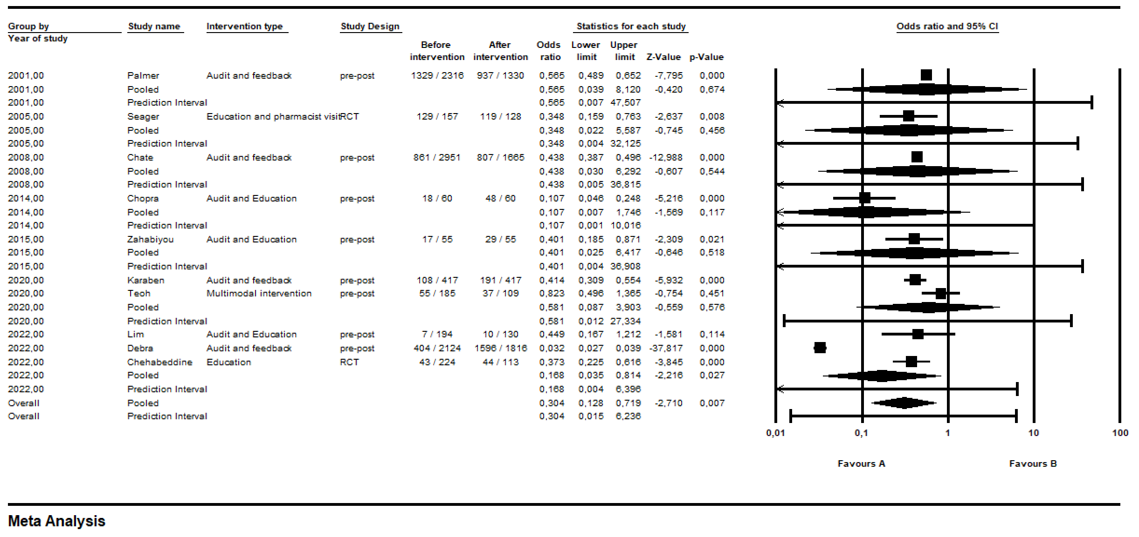

**Figure S3.** Meta-analysis by specialization

