Supporting Information to

Moura, MR., HC Costa, AD Abegg, E Alaminos, T Angarita-Sierra, WS Azevedo, H Cabral, PS Carvalho, S Cechin, N Citeli, ACM Dourado, AFV Duarte, FGR França, EMX Freire, PCA Garcia, R Montero, ACM Moraes-da-Silva, R Mol, JM Pleguezuelos, RFD Sales, DJ Santana, LC Santos, VTC Silva, V Sudré, DC Passos, P Passos, R Perez, P Prado, A Prudente, O Torres-Carvajal, JJ Torres-Ramirez, V Wallach, GR Winck, and JJM Guedes. Unwrapping broken tails: biological and environmental correlates of predation pressure in limbless reptiles. Journal of Animal Ecology, 2022.

Appendix S1 – Additional figures and tables.

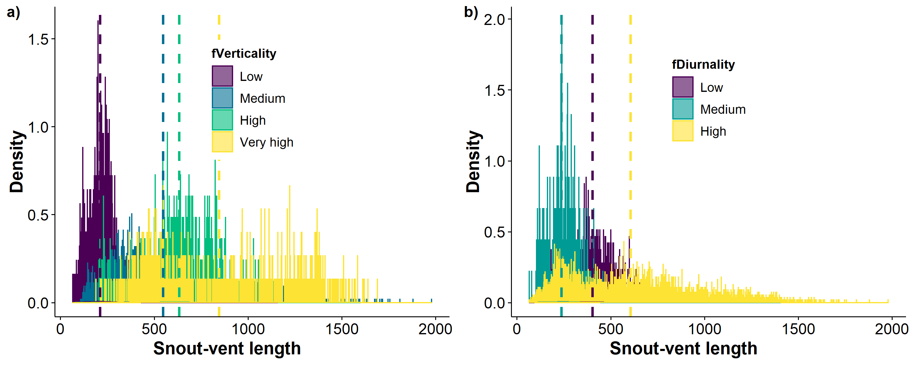
Figure S1. Body size (snout-vent length, in mm) frequency distribution for specimens in our study across levels of (a) verticality and (b) diurnality. Vertical line denotes the mean value of snout-vent length observed for the respective level of verticality or diurnality.

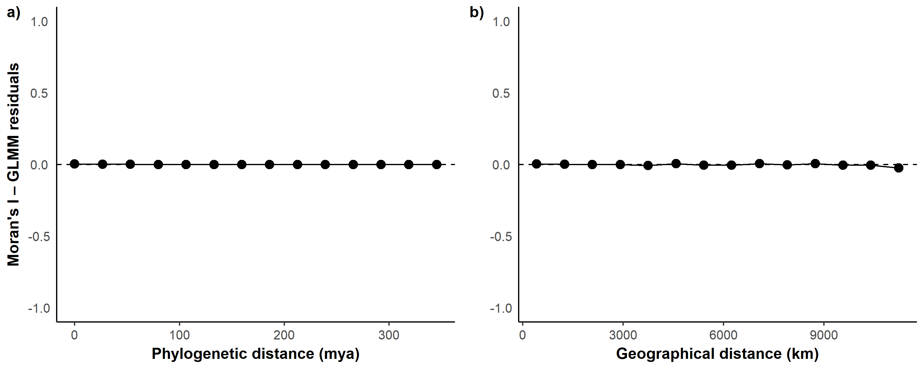
Figure S2. Spatial and phylogenetic structure in Generalized Linear Mixed Model (GLMM) residuals. (a) Phylogenetic correlogram. (b) Spatial correlogram. Each point denotes the average Moran’s I value across sample pairs within the respective distance class interval.

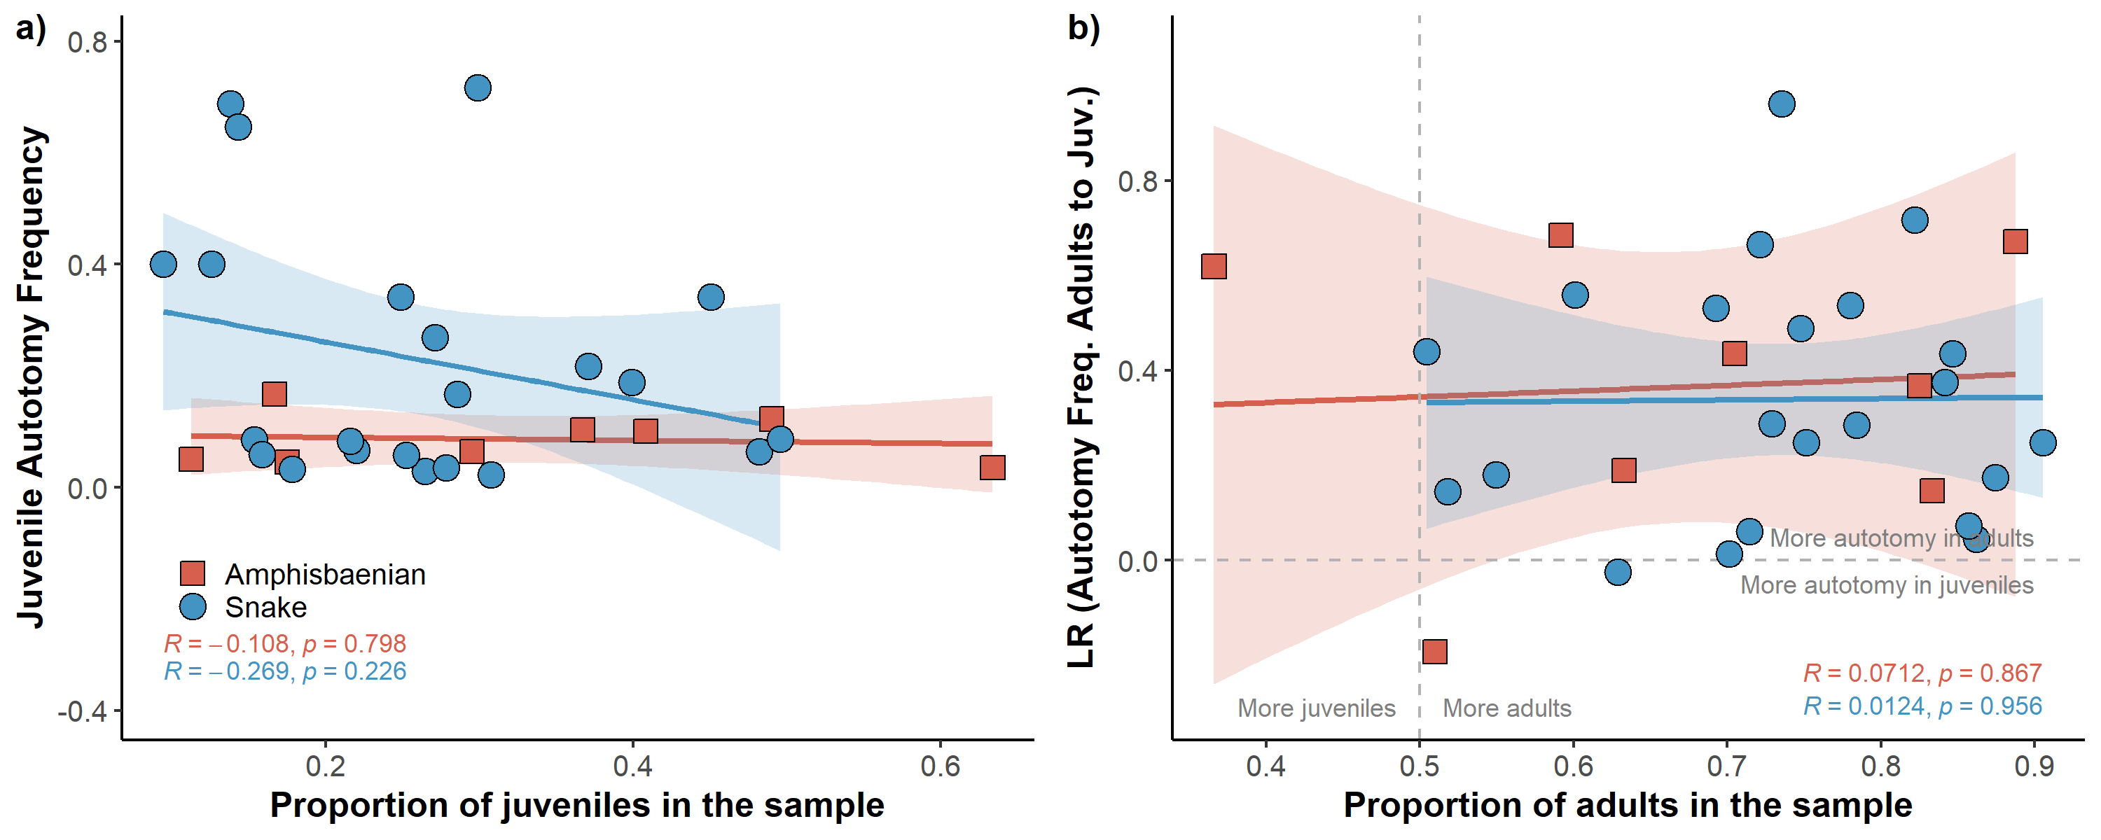
Figure S3. Relationship between autotomy frequency and life-stage in snake and amphisbaenian species. Log ratio (LR) of autotomy frequency of adult to juvenile > 0 indicates more autotomy in adults than juveniles. R denotes the Pearson correlation coefficient.

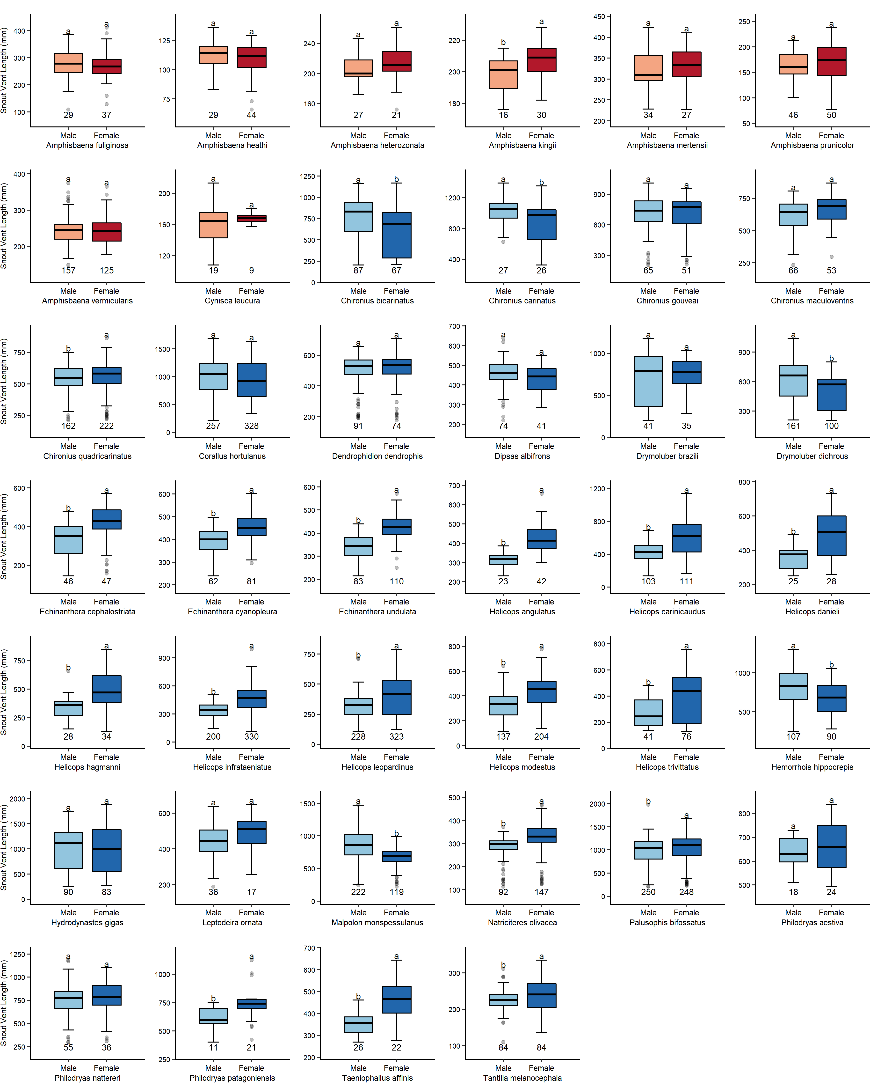
Figure S4. Sexual size dimorphism in snout-vent length for snake and amphisbaenian species. Small letters in the box plots denote Kruskal–Wallis tests of differences in median snout-vent length (mm) between male and female specimens examined in this study. Only species with at least 25 sexed specimens are plotted. Reddish and bluish colours indicate amphisbaenian and snake species, respectively. Sample size s shown below each box.
Table S1. Approach used to determine life-stage and sex of snake and amphisbaenian specimens used in this study.
Species | Approach used to determine life-stage and sex | Examiner of specimens | Source
Amphisbaenians
- Amphisbaena bolivica | Inspection of specimens for sexual traits (sex) + Minimum SVL of sexually mature specimens of the closely-related species A. mertensi (life-stage). | Costa, H.C. and Montero, R. | ¹
- Amphisbaena fuliginosa | Minimum SVL of sexually mature specimens | Angarita-Sierra, T. and Torres-Ramirez, J.J. | ²
- Amphisbaena heathi | Inspection of specimens for sexually mature traits + Minimum SVL of sexually mature specimens | Freire, E.M.X., Passos, D.C., and Sales, R.F.D. | ³
- Amphisbaena heterozonata | Inspection of specimens for sexually mature traits | Montero, R. | This study
- Amphisbaena littoralis | Minimum SVL of sexually mature specimens of the closely-related species A. vermicularis (life-stage) | Freire, E.M.X. and Sales, R.F.D. | ⁴
- Amphisbaena kingii | Inspection of specimens for sexually mature traits + Minimum SVL of sexually mature specimens | Montero, R. and Santos, L.C. | ¹
- Amphisbaena mertensi | Inspection of specimens for sexually mature traits + Minimum SVL of sexually mature specimens | Montero, R. and Santos, L.C. | ¹
- Amphisbaena munoai | Inspection of specimens for sexually mature traits + Minimum SVL of sexually mature specimens | Montero, R. and Perez, R. | ⁵
- Amphisbaena prunicolor | Inspection of specimens for sexually mature traits + Minimum SVL of sexually mature specimens | Montero, R. and Perez, R. | ⁵
- Amphisbaena vermicularis | Inspection of specimens for sexual traits (sex) + Minimum SVL of sexually mature specimens (life-stage) | Costa, H.C., Passos, D.C., and Santos L.C. | ⁴
- Cynisca leucura | Inspection of specimens for sexually mature traits | Santos, L.C. | ¹
Snakes
- Chironius bicarinatus | Inspection of specimens for sexual traits (sex) + Minimum SVL of sexually mature specimens of the closely-related species C. quadricarinatus (life-stage) | Mol, R. and Sudré, V. | ⁶
- Chironius carinatus | Inspection of specimens for sexual traits (sex) + Minimum SVL of sexually mature specimens of the closely-related species C. quadricarinatus (life-stage) | Sudré, V. | ⁶
- Chironius gouveai | Inspection of specimens for sexual traits (sex) + Minimum SVL of sexually mature specimens of the closely-related species C. quadricarinatus (life-stage) | Sudré, V. | ⁶
- Chironius maculoventris | Inspection of specimens for sexual traits (sex) + Minimum SVL of sexually mature specimens of the closely-related species C. quadricarinatus (life-stage) | Sudré, V. | ⁶
- Chironius quadricarinatus | Inspection of specimens for sexual traits (sex) + Minimum SVL of sexually mature specimens (life-stage) | Mol, R. and Sudré, V. | ⁶
- Corallus hortulanus | Minimum SVL of sexually mature specimens | Passos, P. | ⁷
- Dendrophidion dendrophis | Inspection of specimens for sexually mature traits + Minimum SVL of sexually mature specimens | Dourado, A., Passos, P., and Prudente, A. L. C. | ^{8,9}
- Dipsas albifrons | Minimum SVL of sexually mature specimens | Passos, P. | ¹⁰
- Drymoluber brazili | Inspection of specimens for sexual traits (sex) + Ontogenic variation in colour pattern (life-stage) | Costa, H.C. | ¹¹
- Drymoluber dichrous | Inspection of specimens for sexual traits (sex) + Ontogenic variation in colour pattern (life-stage) | Costa, H.C. | ¹¹
- Echinanthera cephalostriata | Inspection of specimens for sexual traits (sex) + Minimum SVL of sexually mature specimens of the closely-related species E. cyanopleura (life-stage) | Abegg, A. | ¹²
- Echinanthera cyanopleura | Inspection of specimens for sexually mature traits + Minimum SVL of sexually mature specimens | Cechin, S. | ⁸
- Echinanthera undulata | Inspection of specimens for sexual traits (sex) + Minimum SVL of sexually mature specimens (life-stage) | Abegg, A. | ¹³
- Helicops angulatus | Minimum SVL of sexually mature specimens | Mol, R., and Passos, P. | ¹⁴
- Helicops carinicaudus | Minimum SVL of sexually mature specimens | Mol, R. and Moraes-da-Silva, A. | ¹⁴
- Helicops danieli | Inspection of specimens for sexually mature traits + Minimum SVL of sexually mature specimens (life-stage) + Ontogenic variation in colour pattern (life-stage) | Citeli, N. | ¹⁵
- Helicops hagmanni | Minimum SVL of sexually mature specimens | Citeli, N. | ¹⁴
- Helicops infrataeniatus | Minimum SVL of sexually mature specimens | Moraes-da-Silva, A. | ¹⁶
- Helicops leopardinus | Minimum SVL of sexually mature specimens | Mol, R. and Moraes-da-Silva, A. | ¹⁷
- Helicops modestus | Minimum SVL of sexually mature specimens | Mol, R. and Moraes-da-Silva, A. | ¹⁴
- Helicops trivittatus | Minimum SVL of sexually mature specimens | Moraes-da-Silva, A. | ¹⁴
- Hemorrhois hippocrepis | Inspection of specimens for sexually mature traits + Minimum SVL of sexually mature specimens | Alaminos, E. and Pleguezuelos, J. M. | ¹⁸
- Hydrodynastes gigas | Minimum SVL of sexually mature specimens | Carvalho, P.S. | ¹⁹
- Leptodeira ornata | Inspection of specimens for sexually mature traits + Minimum SVL of sexually mature specimens | Torres-Carvajal, O. | This study
- Malpolon monspessulanus | Inspection of specimens for sexually mature traits + Minimum SVL of sexually mature specimens | Alaminos, E. and Pleguezuelos, J. M. | ²⁰
- Natriciteres olivacea | Inspection of specimens for sexually mature traits | Wallach, V. | This study
- Palusophis bifossatus | Minimum SVL of sexually mature specimens | Dourado, A. and Prudente, A. L. C. | ^{9,21}
- Philodryas aestiva | Inspection of specimens for sexually mature traits + Minimum SVL of sexually mature specimens | Cabral, H. | ²²
- Philodryas nattereri | Inspection of specimens for sexually mature traits + Minimum SVL of sexually mature specimens | Cabral, H., Freire, E.M.X, Passos, P., and Sales, R.F.D. | ²³
- Philodryas patagoniensis | Inspection of specimens for sexually mature traits + Minimum SVL of sexually mature specimens | Cabral, H. | ²²
- Taeniophallus affinis | Inspection of specimens for sexual traits (sex) + Minimum SVL of sexually mature specimens (life-stage) | Abegg, A. and Prado, P. | ²⁴
- Tantilla melanocephala | Inspection of specimens for sexual traits (sex) + Minimum SVL of sexually mature specimens | Azevedo, W.S., Freire, E.M.X., and Sales, R.F.D. | ^{25,26}
- Zamenis scalaris | Inspection of specimens for sexually mature traits + Minimum SVL of sexually mature specimens | Alaminos, E. and Pleguezuelos, J. M. | ²⁷
1. Santos, L. C. Biologia reprodutiva comparada de Amphisbaenidae (Squamata, Amphisbaenia) do Brasil. (Universidade de São Paulo, 2013).
2. Vanzolini, P. E. Contributions to the knowledge of the Brasilian lizards of the family Amphisbaenidae Gray, 1825. 6. On the geographical distribution and differentiation of Amphisbaena fuliginosa Linné. Bull. Museum Comp. Zool. 106, 1–67 (1951).
3. Oliveira, C. R., Roberto, I. J., Gonçalves-Sousa, J. G. & Ávila, R. W. On the ecology of Amphisbaena heathi (Squamata: Amphisbaenidae) from Northeastern Brazil. Herpetol. Rev. 50, 62–66 (2019).
4. Guedes, J. J. M., Costa, H. C. & Moura, M. R. A new tale of lost tails: Correlates of tail breakage in the worm lizard Amphisbaena vermicularis. Ecol. Evol. 10, 14247–14255 (2020).
5. Perez, R. & Borges-Martins, M. Integrative taxonomy of small worm lizards from Southern South America, with description of three new species (Amphisbaenia: Amphisbaenidae). Zool. Anz. 283, 124–141 (2019).
6. Pinto, R. R., Marques, O. A. V & Fernandes, R. Reproductive biology of two sympatric colubrid snakes, Chironius flavolineatus and Chironius quadricarinatus, from the Brazilian Cerrado domain. Amphibia-Reptilia 31, 463–473 (2010).
7. Henderson, R. W. Neotropical Treeboa’s: Natural History of the Common Corallus hortulanus Complex. (Krieger Publisher, 2002).
8. Prudente, A. L. C., Maschio, G. F., Yamashina, C. E. & Santos-Costa, M. C. Morphology, reproductive biology and diet of Dendrophidion dendrophis (Schlegel, 1837)(Serpentes, Colubridae) in Brazilian Amazon. South Am. J. Herpetol. 2, 53–58 (2007).
9. Dourado, Â. C. M., Oliveira, L. & Prudente, A. L. C. Pseudoautotomy in Dendrophidion dendrophis and Mastigodryas bifossatus (Serpentes: Colubridae): Tail Morphology and Breakage Frequency. Copeia 2013, 132–141 (2013).
10. Pizzatto, L. et al. Reproductive ecology of Dipsadine snakes, with emphasis on South American species. Herpetologica 64, 168–179 (2008).
11. Costa, H. C., Moura, M. R. & Feio, R. N. Taxonomic revision of Drymoluber Amaral, 1930 (Serpentes: Colubridae). Zootaxa 3716, 349–394 (2013).
12. Zanella, N. & Cechin, S. Z. Reproductive biology of Echinanthera cyanopleura (Serpentes: Dipsadidae) in southern Brazil. Zool. 27, 30–34 (2010).
13. Gomes, C. A. & Marques, O. A. V. Food Habits, Reproductive Biology, and Seasonal Activity of the Dipsadid Snake, Echinanthera undulata (Wied, 1824), from the Atlantic Forest in Southeastern Brazil. South Am. J. Herpetol. 7, 233–240 (2012).
14. Scartozzoni, R. R. Estratégias reprodutivas e ecologia alimentar de serpentes aquáticas da tribo Hydropsini (Dipsadidae, Xenedontinae). (Universidade de São Paulo, 2009).
15. Citeli, N. et al. Taxonomy, allometry, sexual dimorphism, and conservation of the trans-Andean watersnake Helicops danieli Amaral, 1937 (Serpentes: Dipsadidae: Hydropsini). Can. J. Zool. 100, 184–196 (2022).
16. de Aguiar, L. F. S. & Di-Bernardo, M. Reproduction of the water snake Helicops infrataeniatus (Colubridae) in southern Brazil. Amphibia-Reptilia 26, 527–533 (2005).
17. Ávila, R. W., Ferreira, V. L. & Arruda, J. A. O. Natural History of the South American Water Snake Helicops leopardinus (Colubridae: Hydropsini) in the Pantanal, Central Brazil. J. Herpetol. 40, 274–279 (2006).
18. Pleguezuelos, J. M. & Feriche, M. Reproductive Ecology of the Horseshoe Whip Snake (Coluber hippocrepis) in the Iberian Peninsula. J. Herpetol. 33, 202 (1999).
19. Giraudo, A. R., Arzamendia, V., Bellini, G. P., Bessa, C. A. & Belén Costanzo, M. Ecología de una gran serpiente sudamericana, Hydrodynastes gigas (Serpentes: Dipsadidae). Rev. Mex. Biodivers. 85, 1206–1216 (2014).
20. Feriche, M., Pleguezuelos, J. M. & Santos, X. Reproductive Ecology of the Montpellier Snake, Malpolon monspessulanus (Colubridae), and Comparison with Other Sympatric Colubrids in the Iberian Peninsula. Copeia 2008, 279–285 (2008).
21. Leite, P. T., Nunes, S. F., Kaefer, I. L. & Cechin, S. Z. Reproductive biology of the swamp racer Mastigodryas bifossatus (Serpentes: Colubridae) in subtropical Brazil. Zool. 26, 12–18 (2009).
22. Quintela, F. M. & Loebmann, D. Diet, sexual dimorphism and reproduction of sympatric racers Philodryas aestiva and Philodryas patagoniensis from the coastal Brazilian Pampa. An. Acad. Bras. Cienc. 91, e20180296 (2019).
23. Fowler, I. R. & Salomão, M. G. A new technique to distinguish between immature and adult snakes and between males and females in six species of the neotropical colubrid snakes Philodryas. Stud. Neotrop. Fauna Environ. 30, 149–157 (1995).
24. Gomes, C. A. História natural das serpentes dos gêneros Echinanthera e Taeniophallus (Echinantherini). (Universidade Estadual Paulista, 2012).
25. Marques, O. A. V & Puorto, G. Feeding, reproduction and growth in the crowned snake. Amphibia-Reptilia 19, 311–318 (1998).
26. Santos-Costa, M. C., Prudente, A. L. C. & Di-Bernardo, M. Reproductive Biology of Tantilla melanocephala (Linnaeus, 1758) (Serpentes, Colubridae) from Eastern Amazonia, Brazil. J. Herpetol. 40, 553–556 (2009).
27. Pleguezuelos, J. M. & Feriche, M. Reproductive ecology of a Mediterranean ratsnake, the ladder snake Rhinechis scalaris (Schinz, 1822). Herpetol. J. 16, 177–182 (2006).

Table S2. Variance Inflation Factor (VIF) for predictors of probability of tail loss in limbless reptiles. VIF measures the multicollinearity of variables included in a model, and it varies from 1 (no multicollinearity) to +Inf. VIF values > 10 reflect high multicollinearity.
Predictor | VIF
Life-stage | 1.065
Body size | 1.053
Sex | 1.010
Verticality | 1.052
Diurnality | 1.219
Temperature | 3.089
Precipitation | 1.622
Tropicality | 2.454

Table S3. Generalized Mixed Effect Model (GLMM) for the probability of tail loss among snake and amphisbaenian specimens. Likelihood Ratio Tests (LRT) were applied in a backward selection procedure starting with the full model. Predictor coefficients (Coef., Lower CI and Upper CI) are showed as odds ratio (instead of logit scale). Coefficient values >1 indicates the proportional increase in chances of tail loss (odds ratio) if the respective predictor value changes from 0 (min) to 1 (max), and the inverse occurs for coef. values <1. Predictors are not significant if confidence intervals encompass the value of 1.
Predictor | LRT | P value | Coef. | Lower CI | Upper CI
GLMM output using only sexed specimens (N = 7,346)
Life-stage | 234.514 | <0.001 | 3.599 | 3.022 | 4.286
Body size | 120.274 | <0.001 | 3.869 | 3.030 | 4.940
Sex | 27.587 | <0.001 | 1.385 | 1.226 | 1.565
Verticality | 4.297 | 0.038 | 3.506 | 1.105 | 11.123
Diurnality | 4.039 | 0.044 | 2.179 | 1.045 | 4.541
Temperature | 3.924 | 0.047 | 2.220 | 1.010 | 4.882
Adj. R² = 22.7% (15.5% random effects and 7.2% fixed effects)
GLMM output with body size rescaled across all species* (N = 8,189)
Body size | 197.083 | <0.001 | 321.471 | 143.597 | 679.942
Suborder (Serpentes) | 6.590 | 0.010 | 0.346 | 0.156 | 0.765
Sex | 5.421 | 0.019 | 1.192 | 1.031 | 1.379
Temperature | 4.352 | 0.036 | 2.278 | 1.053 | 4.932
Adj. R² = 23.5% (18.5% random effects and 5.01% fixed effects)
GLMM output, same as above but using only sexed specimens* (N = 7,346)
Body size | 170.548 | <0.001 | 226.285 | 103.208 | 496.131
Sex | 6.381 | 0.011 | 1.197 | 1.043 | 1.375
Biome (ref=Deserts/Xeric Shrub.) | 15.433 | 0.030
Biome:Flooded Grass./Savannas | - | - | 0.347 | 0.025 | 4.813
Biome:Mangroves | - | - | 0.279 | 0.020 | 3.805
Biome:Medit. Forests/Woodlands | - | - | 0.055 | 0.003 | 0.889
Biome:Temp. Grass./Savannas | - | - | 0.538 | 0.038 | 7.530
Biome:Trop/Sub. Dry Forest. | - | - | 0.320 | 0.024 | 4.234
Biome:Trop/Sub. Grass./Savan. | - | - | 0.341 | 0.026 | 4.482
Biome:Trop/Sub. Moist Forest. | - | - | 0.296 | 0.023 | 3.868
Adj. R² = 23.5% (16.6% random effects and 6.9% fixed effects)
* GLMM with nested random structure (1|Species + 1|Species:Sex + 1|Species:LifeStage).

