SUPPORTING INFORMATION

Diversity and dominance in bird assemblages across habitats in the Ñeembucú Wetlands Complex

Fátima Ortiz¹, Patricia Salinas¹, Medes Mendoza¹, Griselda Zárate¹, Fátima Piris da Motta¹, Alberto Esquivel², Karina Núñez¹, and Fernando Silla^{3*}

¹ Escuela de Biología, Facultad de Ciencias Exactas y Naturales (FACEN), Universidad Nacional de Asunción, Paraguay
² Wildlife Paraguay, Benito Juárez, Luque, Paraguay
³ Área de Ecología, Facultad de Biología, Universidad de Salamanca, Spain

* Corresponding autor: fsilla@usal.es - Área de Ecología, Facultad de Biología, Campus Unamuno s/n, Universidad de Salamanca, Salamanca (Spain)

Figure S1. Dominant habitat types in the Ñeembucú Wetlands Complex: a) riparian forests, b) savannas (dominated by the palm Copernicia alba), c) natural grasslands, d) anthropized habitats, e) and an aerial photograph taken from Google Earth (© 2024 Google) from 2021 of the Villafranca sector showing some representative sample points (green: riparian forests; orange: grasslands; blue: palm savannas; purple: anthropized sites).
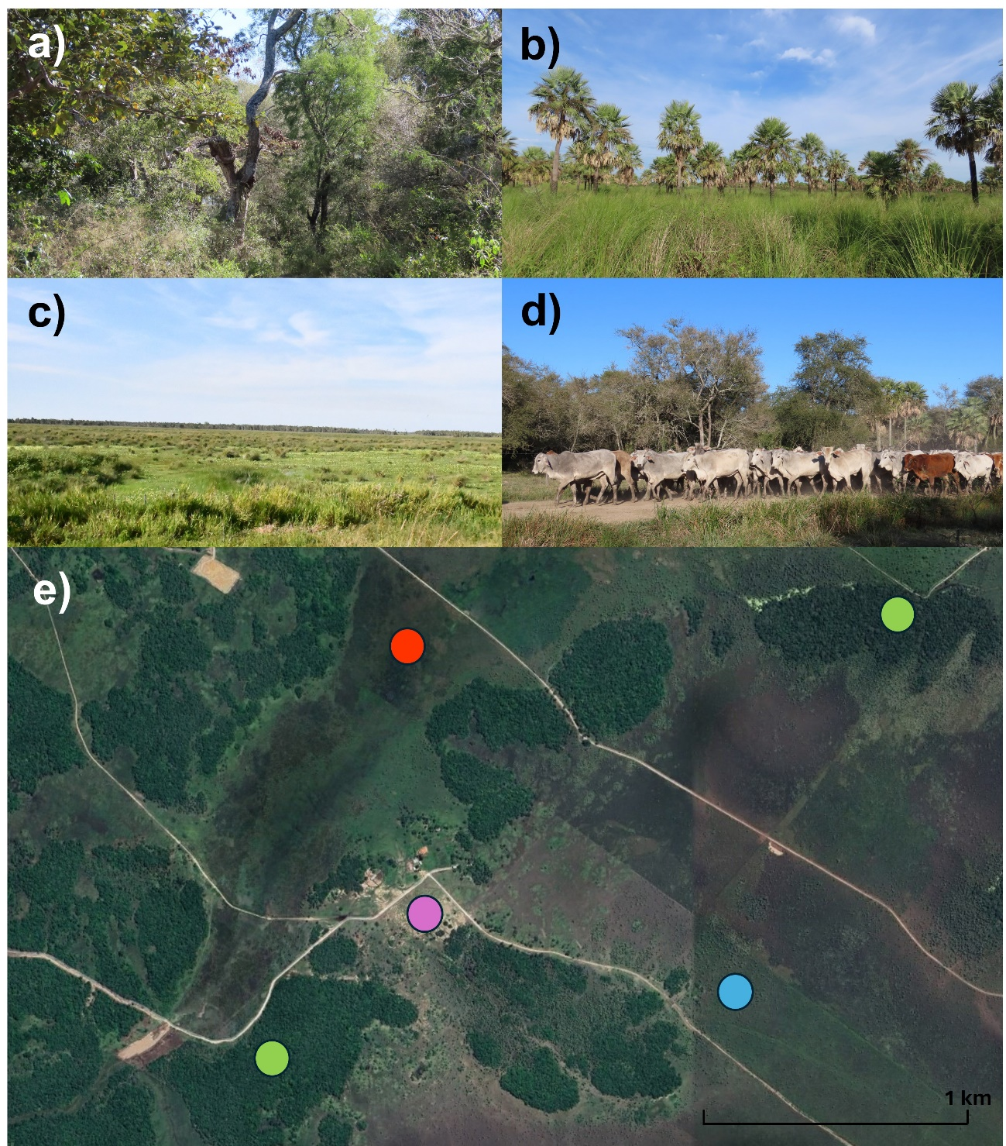

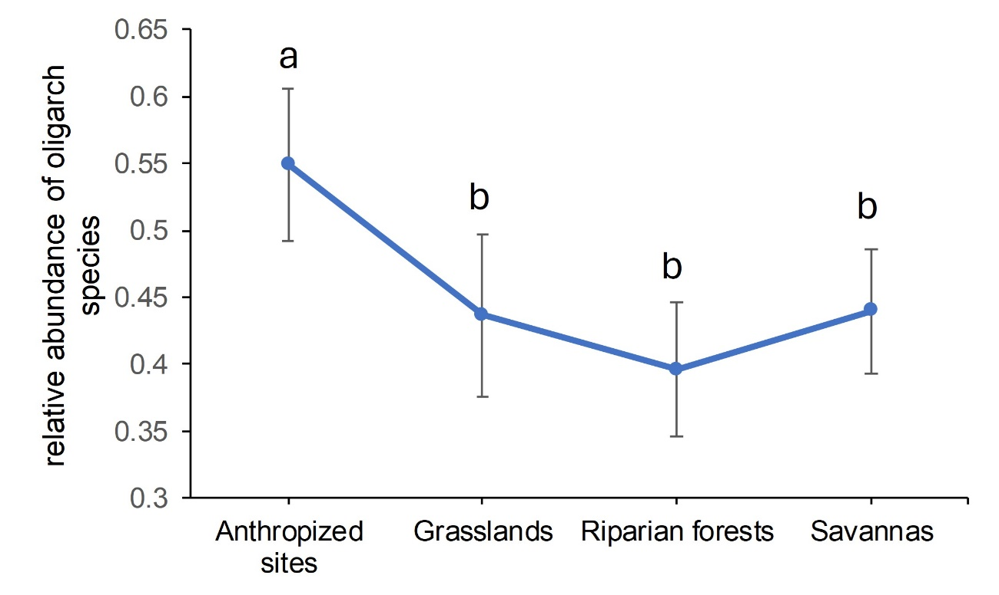
Figure S2. Mean relative abundance of oligarch species per habitat type (error bars show 95% confidence intervals). Different letters indicate significative differences (p < 0.05) between habitat types using post-hoc Tukey’s tests.

Figure S3. Non-metric Multidimensional Analysis of the bird assemblages sampled at each point counts (dots) for the four habitat types during the dry season. Solid lines of the ellipsoids indicate standard deviations of the centroids. Stress value: 0.1830.
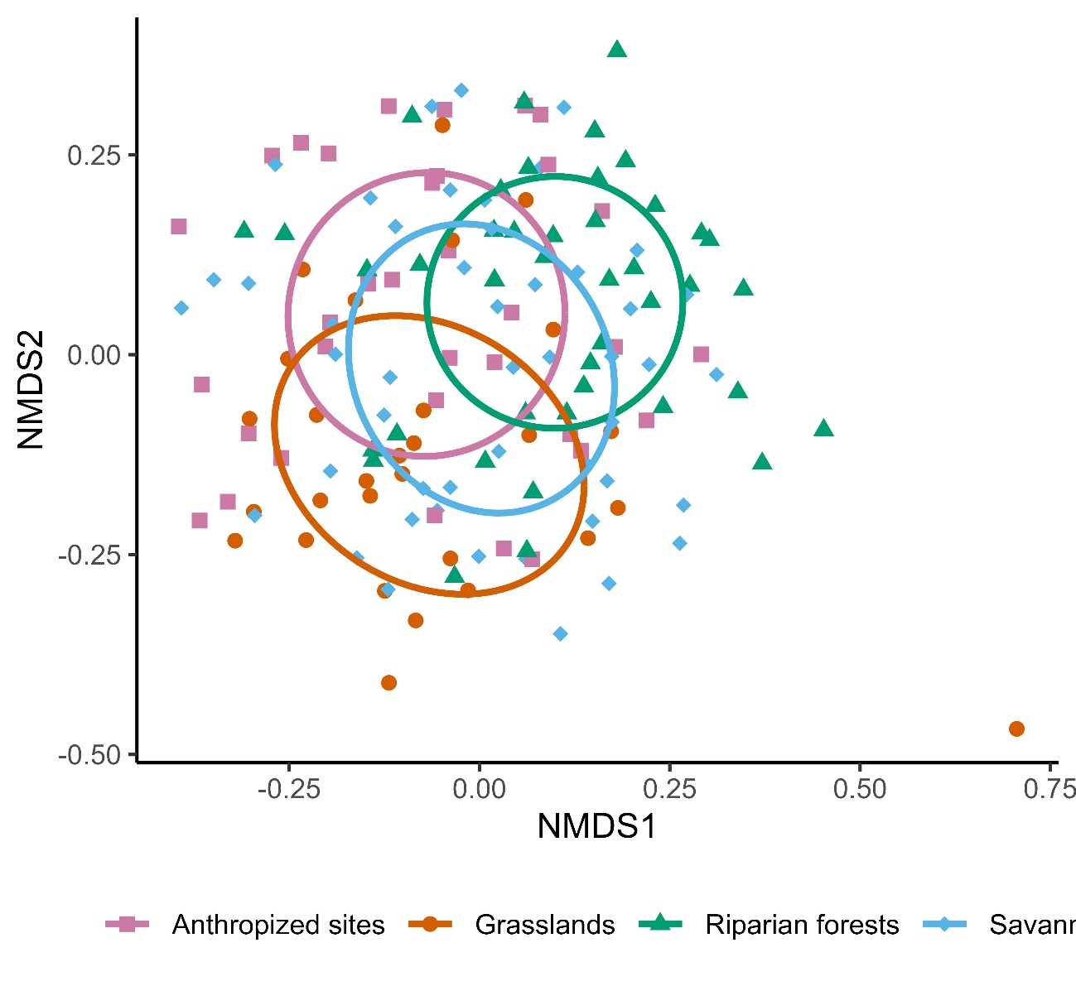

Figure S4. Non-metric Multidimensional Scaling Analysis of the bird assemblages sampled at each point counts (dots) for the four habitat types during the wet season. Solid lines of the ellipsoids indicate standard deviations of the centroids. Stress value: 0.1821.

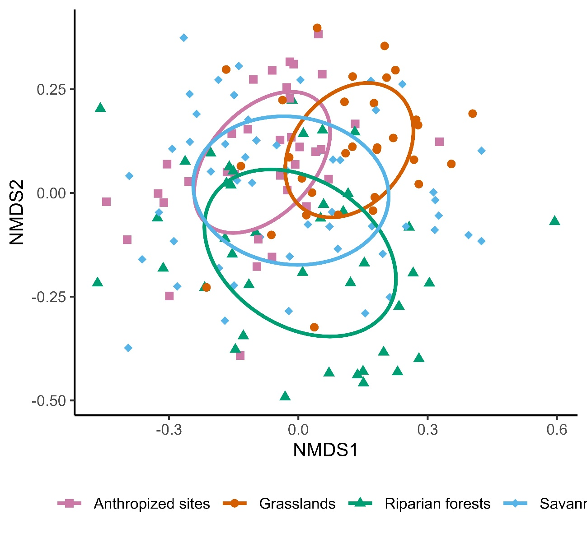

Table S1. Similarity percentage analyses (SIMPER) between pair of habitats showing the average abundance (Aver.Abund)) of each species in each habitat. Species were ordered from the species with the highest contribution to the dissimilarity among habitats to the species with the lowest contribution up to a cumulative contribution of 70%. Oligarch species are indicated in bold characters. Species that significantly contributed with these differences are indicated (**P <0.01; *P <0.05; .P <0.1).
Groups Anthropized sites vs Riparian Forests
Species | Group  Anthr. sites Aver.Abund | Group  Rip. Forests Aver.Abund | Contrib (Cumulative %) | P-value
Myiopsitta monachus | 6.214 | 2.6279 | 7.0 | 0.262
Progne tapera | 4.786 | 2.0698 | 12.5 | 0.004 | **
Vanellus chilensis | 4.314 | 1.7326 | 16.9 | 0.594
Patagioenas picazuro | 1.743 | 1.3023 | 19.5 | 0.541
Paroaria coronata | 1.886 | 1.1628 | 22.0 | 0.355
Molothrus bonariensis | 1.986 | 0.0349 | 24.2 | 0.241
Furnarius rufus | 1.914 | 1.407 | 26.5 | 0.533
Phacellodomus ruber | 1.857 | 1.1628 | 28.7 | 0.445
Tyrannus melancholicus | 1.843 | 0.686 | 30.7 | 0.021 | *
Guira guira | 1.171 | 1.186 | 32.8 | 0.847
Sicalis flaveola | 1.257 | 1.0349 | 34.6 | 0.194
Cyanocorax chrysops | 0.257 | 1.5349 | 36.5 | 0.171
Columbina picui | 1.114 | 0.8256 | 38.3 | 0.678
Aramides ypecaha | 1.071 | 1.1395 | 40.0 | 0.433
Forpus xanthopterygius | 1 | 0.7209 | 41.8 | 0.120
Saltator coerulescens | 0.614 | 1.3256 | 43.5 | 0.486
Phimosus infuscatus | 1.814 | 0.3256 | 45.1 | 0.155
Machetornis rixosa | 1.271 | 0.2442 | 46.5 | 0.044 | *
Coragyps atratus | 0.429 | 1.0465 | 48.0 | 0.751
Amazonetta brasiliensis | 0.8 | 0.6744 | 49.4 | 0.139
Ortalis canicollis | 0.543 | 0.7791 | 50.8 | 0.632
Crotophaga ani | 0.929 | 0.3721 | 52.2 | 0.102
Xolmis irupero | 1.014 | 0.593 | 53.4 | 0.06 | .
Pitangus sulphuratus | 1.043 | 0.5814 | 54.7 | 0.711
Thraupis sayaca | 0.729 | 0.6512 | 55.9 | 0.08 | .
Schoeniophylax phryganophilus | 0.914 | 0.3837 | 57.1 | 0.777
Zonotrichia capensis | 0.943 | 0.4186 | 58.3 | 0.291
Tachycineta leucorrhoa | 1 | 0.1744 | 59.4 | 0.362
Agelaioides badius | 0.657 | 0.4651 | 60.5 | 0.144
Zenaida auriculata | 0.414 | 0.6977 | 61.5 | 0.731
Cyclarhis gujanensis | 0.243 | 0.7442 | 62.5 | 0.004 | **
Colaptes campestris | 0.557 | 0.5116 | 63.5 | 0.275
Paroaria capitata | 0.686 | 0.2558 | 64.5 | 0.102
Euphonia chlorotica | 0.5 | 0.5349 | 65.4 | 0.055 | .
Coryphistera alaudina | 0.4 | 0.3372 | 66.3 | 0.418
Ammodramus humeralis | 0.429 | 0.3837 | 67.1 | 0.847
Polioptila dumicola | 0.543 | 0.3023 | 67.9 | 0.181
Rupornis magnirostris | 0.186 | 0.5116 | 68.6 | 0.049 | *
Crotophaga major | 0 | 0.6279 | 69.3 | 0.193
Taraba major | 0.143 | 0.5233 | 70.0 | 0.258
Contribution of oligarch species |  |  | 42.6
Contribution of species showing significant differences |  |  | 13.0
Contribution of oligarch species showing significant differences |  |  | 7.5
Groups Anthropized sites vs Grasslands
Species | Group  Anthr. sites Aver.Abund | Group  Grasslands Aver.Abund | Contrib (Cumulative %) | P-value
Myiopsitta monachus | 6.214 | 2.85 | 7.2 | 0.242
Vanellus chilensis | 4.314 | 4.35 | 12.6 | 0.078 | .
Progne tapera | 4.786 | 1.217 | 17.7 | 0.016 | *
Molothrus bonariensis | 1.986 | 1.3 | 20.7 | 0.023 | *
Guira guira | 1.171 | 2.183 | 23.7 | 0.08 | .
Furnarius rufus | 1.914 | 1.6 | 26.2 | 0.209
Phacellodomus ruber | 1.857 | 1.483 | 28.6 | 0.227
Patagioenas picazuro | 1.743 | 0.933 | 31.0 | 0.765
Paroaria coronata | 1.886 | 0.983 | 33.2 | 0.683
Phimosus infuscatus | 1.814 | 0.8 | 35.3 | 0.046 | *
Tyrannus melancholicus | 1.843 | 0.733 | 37.3 | 0.069 | .
Columbina picui | 1.114 | 1.133 | 39.3 | 0.482
Aramides ypecaha | 1.071 | 1.267 | 41.1 | 0.344
Sicalis flaveola | 1.257 | 0.7 | 42.8 | 0.633
Machetornis rixosa | 1.271 | 0.683 | 44.5 | 0.005 | **
Forpus xanthopterygius | 1 | 0.5 | 45.9 | 0.324
Ortalis canicollis | 0.543 | 0.85 | 47.4 | 0.612
Tachycineta leucorrhoa | 1 | 0.433 | 48.7 | 0.213
Mycteria americana | 0.371 | 0.917 | 50.0 | 0.006 | **
Pitangus sulphuratus | 1.043 | 0.683 | 51.3 | 0.622
Coragyps atratus | 0.429 | 0.85 | 52.5 | 0.786
Schoeniophylax phryganophilus | 0.914 | 0.533 | 53.8 | 0.658
Progne chalybea | 0.471 | 0.733 | 55.0 | 0.005 | **
Xolmis irupero | 1.014 | 0.467 | 56.2 | 0.215
Colaptes campestris | 0.557 | 0.717 | 57.5 | 0.097 | .
Crotophaga ani | 0.929 | 0.133 | 58.6 | 0.331
Saltator coerulescens | 0.614 | 0.65 | 59.8 | 0.989
Amazonetta brasiliensis | 0.8 | 0.317 | 60.9 | 0.487
Pseudoleistes guirahuro | 0.157 | 0.8 | 62.0 | 0.173
Zonotrichia capensis | 0.943 | 0.25 | 63.0 | 0.555
Thraupis sayaca | 0.729 | 0.383 | 64.1 | 0.525
Ammodramus humeralis | 0.429 | 0.733 | 65.1 | 0.441
Campylorhynchus turdinus | 0.343 | 0.6 | 66.1 | 0.393
Zenaida auriculata | 0.414 | 0.633 | 67.1 | 0.801
Paroaria capitata | 0.686 | 0.35 | 68.1 | 0.08 | .
Tyrannus savana | 0.329 | 0.683 | 69.1 | 0.002 | **
Contribution of oligarch species |  |  | 43.2
Contribution of species showing significant differences |  |  | 24.1
Contribution of oligarch species showing significant differences |  |  | 18.5
Groups Anthropized sites vs Savannas
Species | Group  Anthr. sites Aver.Abund | Group  Savannas Aver.Abund | Contrib (Cumulative %) | P-value
Myiopsitta monachus | 6.214 | 5.24 | 7.4 | 0.146
Progne tapera | 4.786 | 1.48 | 12.6 | 0.014 | *
Vanellus chilensis | 4.314 | 2.86 | 17.3 | 0.531
Patagioenas picazuro | 1.743 | 2.13 | 20.1 | 0.295
Molothrus bonariensis | 1.986 | 0.99 | 22.8 | 0.04 | *
Paroaria coronata | 1.886 | 1.72 | 25.5 | 0.185
Phacellodomus ruber | 1.857 | 1.44 | 27.7 | 0.603
Furnarius rufus | 1.914 | 1.42 | 29.8 | 0.912
Tyrannus melancholicus | 1.843 | 0.8 | 31.8 | 0.035 | *
Columbina picui | 1.114 | 1.3 | 33.8 | 0.433
Guira guira | 1.171 | 0.95 | 35.7 | 0.974
Sicalis flaveola | 1.257 | 1.13 | 37.4 | 0.528
Agelasticus cyanopus | 0.6 | 1.33 | 39.0 | 0.053 | .
Aramides ypecaha | 1.071 | 0.93 | 40.6 | 0.908
Schoeniophylax phryganophilus | 0.914 | 0.95 | 42.2 | 0.137
Chauna torquata | 0.129 | 1.67 | 43.8 | 0.357
Machetornis rixosa | 1.271 | 0.43 | 45.3 | 0.055 | .
Phimosus infuscatus | 1.814 | 0.15 | 46.7 | 0.304
Crotophaga ani | 0.929 | 0.43 | 48.1 | 0.099 | .
Saltator coerulescens | 0.614 | 1 | 49.5 | 0.947
Pitangus sulphuratus | 1.043 | 1.01 | 50.9 | 0.422
Tachycineta leucorrhoa | 1 | 0.54 | 52.2 | 0.102
Zonotrichia capensis | 0.943 | 0.68 | 53.6 | 0.091 | .
Coragyps atratus | 0.429 | 0.88 | 54.9 | 0.882
Forpus xanthopterygius | 1 | 0.3 | 56.1 | 0.519
Ortalis canicollis | 0.543 | 0.71 | 57.3 | 0.88
Amazonetta brasiliensis | 0.8 | 0.52 | 58.5 | 0.449
Cyanocorax chrysops | 0.257 | 0.91 | 59.7 | 0.936
Xolmis irupero | 1.014 | 0.64 | 60.8 | 0.461
Thraupis sayaca | 0.729 | 0.38 | 61.8 | 0.571
Molothrus rufoaxillaris | 0.386 | 0.62 | 62.8 | 0.027 | *
Paroaria capitata | 0.686 | 0.31 | 63.7 | 0.129
Agelaioides badius | 0.657 | 0.27 | 64.6 | 0.429
Zenaida auriculata | 0.414 | 0.57 | 65.5 | 0.965
Coryphistera alaudina | 0.4 | 0.4 | 66.4 | 0.457
Campylorhynchus turdinus | 0.343 | 0.5 | 67.2 | 0.681
Ammodramus humeralis | 0.429 | 0.56 | 68.1 | 0.853
Caracara plancus | 0.4 | 0.39 | 68.9 | 0.236
Polioptila dumicola | 0.543 | 0.29 | 69.6 | 0.36
Contribution of oligarch species |  |  | 43.1
Contribution of species showing significant differences |  |  | 16.8
Contribution of oligarch species showing significant differences |  |  | 9.9
Groups Riparian Forests vs Grasslands
Species | Group  Rip. Forests Aver.Abund | Group  Grasslands Aver.Abund | Contrib (Cumulative %) | P-value
Vanellus chilensis | 1.7326 | 4.35 | 5.2 | 0.073 | .
Myiopsitta monachus | 2.6279 | 2.85 | 10.1 | 0.989
Guira guira | 1.186 | 2.183 | 13.4 | 0.002 | **
Progne tapera | 2.0698 | 1.217 | 16.5 | 0.91
Furnarius rufus | 1.407 | 1.6 | 19.0 | 0.029 | *
Phacellodomus ruber | 1.1628 | 1.483 | 21.3 | 0.334
Patagioenas picazuro | 1.3023 | 0.933 | 23.3 | 0.949
Coragyps atratus | 1.0465 | 0.85 | 25.4 | 0.131
Aramides ypecaha | 1.1395 | 1.267 | 27.4 | 0.037 | *
Saltator coerulescens | 1.3256 | 0.65 | 29.3 | 0.126
Paroaria coronata | 1.1628 | 0.983 | 31.2 | 0.948
Columbina picui | 0.8256 | 1.133 | 33.1 | 0.49
Cyanocorax chrysops | 1.5349 | 0 | 34.8 | 0.157
Ortalis canicollis | 0.7791 | 0.85 | 36.6 | 0.165
Sicalis flaveola | 1.0349 | 0.7 | 38.2 | 0.641
Zenaida auriculata | 0.6977 | 0.633 | 39.7 | 0.059 | .
Tyrannus melancholicus | 0.686 | 0.733 | 41.0 | 0.909
Forpus xanthopterygius | 0.7209 | 0.5 | 42.3 | 0.38
Molothrus bonariensis | 0.0349 | 1.3 | 43.6 | 0.841
Colaptes campestris | 0.5116 | 0.717 | 44.9 | 0.032 | *
Mycteria americana | 0.0698 | 0.917 | 46.1 | 0.01 | **
Ammodramus humerali | 0.3837 | 0.733 | 47.3 | 0.1 | .
Pitangus sulphuratus | 0.5814 | 0.683 | 48.5 | 0.886
Phimosus infuscatus | 0.3256 | 0.8 | 49.6 | 0.449
Campylorhynchus turdinus | 0.2326 | 0.6 | 50.7 | 0.274
Embernagra platensis | 0.2907 | 0.7 | 51.7 | 0.007 | **
Pseudoleistes guirahuro | 0 | 0.8 | 52.8 | 0.136
Thraupis sayaca | 0.6512 | 0.383 | 53.8 | 0.414
Machetornis rixosa | 0.2442 | 0.683 | 54.8 | 0.648
Amazonetta brasiliensis | 0.6744 | 0.317 | 55.8 | 0.553
Bubulcus ibis | 0 | 1.25 | 56.9 | 0.001 | ***
Xolmis irupero | 0.593 | 0.467 | 57.9 | 0.758
Cyclarhis gujanensis | 0.7442 | 0.033 | 58.8 | 0.024 | *
Progne chalybea | 0 | 0.733 | 59.7 | 0.052 | .
Schoeniophylax phryganophilus | 0.3837 | 0.533 | 60.7 | 0.949
Tyrannus savana | 0 | 0.683 | 61.6 | 0.001 | ***
Taraba major | 0.5233 | 0.3 | 62.5 | 0.008 | **
Euphonia chlorotica | 0.5349 | 0.2 | 63.3 | 0.101
Syrigma sibilatrix | 0.3837 | 0.433 | 64.2 | 0.117
Agelaioides badius | 0.4651 | 0.333 | 65.0 | 0.449
Aratinga nenday | 0.3721 | 0.3 | 65.9 | 0.4
Rupornis magnirostris | 0.5116 | 0.217 | 66.7 | 0.01 | **
Crotophaga major | 0.6279 | 0 | 67.4 | 0.129
Rostrhamus sociabilis | 0.0233 | 0.533 | 68.2 | 0.001 | ***
Myiarchus tyrannulus | 0.4651 | 0.233 | 68.9 | 0.014 | *
Microspingus melanoleucus | 0.4884 | 0.133 | 69.6 | 0.217
Contribution of oligarch species |  |  | 38.5
Contribution of species showing significant differences |  |  | 26.2
Contribution of oligarch species showing significant differences |  |  | 13.0
Groups Riparian Forests vs Savannas
Species | Group  Rip. Forests Aver.Abund | Group  Savannas Aver.Abund | Contrib (Cumulative %) | P-value
Myiopsitta monachus | 2.6279 | 5.24 | 6.7 | 0.403
Vanellus chilensis | 1.7326 | 2.86 | 10.4 | 0.986
Progne tapera | 2.0698 | 1.48 | 13.7 | 0.941
Patagioenas picazuro | 1.3023 | 2.13 | 16.5 | 0.157
Paroaria coronata | 1.1628 | 1.72 | 19.0 | 0.308
Cyanocorax chrysops | 1.5349 | 0.91 | 21.3 | 0.001 | ***
Furnarius rufus | 1.407 | 1.42 | 23.4 | 0.82
Saltator coerulescens | 1.3256 | 1 | 25.4 | 0.014 | *
Phacellodomus ruber | 1.1628 | 1.44 | 27.5 | 0.808
Guira guira | 1.186 | 0.95 | 29.5 | 0.911
Columbina picui | 0.8256 | 1.3 | 31.4 | 0.433
Coragyps atratus | 1.0465 | 0.88 | 33.4 | 0.17
Chauna torquata | 0.2326 | 1.67 | 35.2 | 0.128
Sicalis flaveola | 1.0349 | 1.13 | 36.9 | 0.357
Aramides ypecaha | 1.1395 | 0.93 | 38.6 | 0.735
Ortalis canicollis | 0.7791 | 0.71 | 40.1 | 0.396
Schoeniophylax phryganophilus | 0.3837 | 0.95 | 41.6 | 0.271
Agelasticus cyanopus | 0.0698 | 1.33 | 43.0 | 0.127
Pitangus sulphuratus | 0.5814 | 1.01 | 44.3 | 0.227
Tyrannus melancholicus | 0.686 | 0.8 | 45.7 | 0.954
Zenaida auriculata | 0.6977 | 0.57 | 47.0 | 0.214
Zonotrichia capensis | 0.4186 | 0.68 | 48.1 | 0.38
Amazonetta brasiliensis | 0.6744 | 0.52 | 49.2 | 0.533
Forpus xanthopterygius | 0.7209 | 0.3 | 50.3 | 0.681
Xolmis irupero | 0.593 | 0.64 | 51.3 | 0.631
Molothrus bonariensis | 0.0349 | 0.99 | 52.4 | 0.98
Thraupis sayaca | 0.6512 | 0.38 | 53.4 | 0.448
Cyclarhis gujanensis | 0.7442 | 0.28 | 54.4 | 0.001 | ***
Ammodramus humeralis | 0.3837 | 0.56 | 55.4 | 0.487
Coryphistera alaudina | 0.3372 | 0.4 | 56.4 | 0.246
Thectocercus acuticaudatus | 0.3953 | 0.48 | 57.3 | 0.026 | *
Crotophaga ani | 0.3721 | 0.43 | 58.2 | 0.676
Crotophaga major | 0.6279 | 0.16 | 59.1 | 0.005 | **
Microspingus melanoleucus | 0.4884 | 0.31 | 60.0 | 0.013 | *
Campylorhynchus turdinus | 0.2326 | 0.5 | 60.8 | 0.613
Aratinga nenday | 0.3721 | 0.52 | 61.7 | 0.343
Euphonia chlorotica | 0.5349 | 0.28 | 62.5 | 0.22
Cacicus chrysopterus | 0.5465 | 0.12 | 63.3 | 0.001 | ***
Agelaioides badius | 0.4651 | 0.27 | 64.1 | 0.643
Syrigma sibilatrix | 0.3837 | 0.41 | 64.9 | 0.27
Turdus rufiventris | 0.4767 | 0.27 | 65.7 | 0.001 | ***
Taraba major | 0.5233 | 0.18 | 66.4 | 0.051 | .
Tachycineta leucorrhoa | 0.1744 | 0.54 | 67.2 | 0.807
Ardea alba | 0.2558 | 0.48 | 68.0 | 0.051 | .
Rupornis magnirostris | 0.5116 | 0.11 | 68.7 | 0.031 | *
Myiarchus tyrannulus | 0.4651 | 0.24 | 69.4 | 0.005 | **
Contribution of oligarch species |  |  | 38.3
Contribution of species showing significant differences |  |  | 11.0
Contribution of oligarch species showing significant differences |  |  | 4.9
Groups Grasslands vs Savannas
Species | Group  Grasslands Aver.Abund | Group  Savannas Aver.Abund | Contrib (Cumulative %) | P-value
Myiopsitta monachus | 2.85 | 5.24 | 6.7 | 0.422
Vanellus chilensis | 4.35 | 2.86 | 12.0 | 0.06 | .
Guira guira | 2.183 | 0.95 | 15.0 | 0.042 | *
Patagioenas picazuro | 0.933 | 2.13 | 17.6 | 0.409
Progne tapera | 1.217 | 1.48 | 20.1 | 0.994
Furnarius rufus | 1.6 | 1.42 | 22.4 | 0.33
Phacellodomus ruber | 1.483 | 1.44 | 24.7 | 0.372
Paroaria coronata | 0.983 | 1.72 | 26.9 | 0.703
Molothrus bonariensis | 1.3 | 0.99 | 28.9 | 0.414
Columbina picui | 1.133 | 1.3 | 30.8 | 0.502
Chauna torquata | 0.383 | 1.67 | 32.6 | 0.176
Coragyps atratus | 0.85 | 0.88 | 34.4 | 0.311
Aramides ypecaha | 1.267 | 0.93 | 36.2 | 0.412
Ortalis canicollis | 0.85 | 0.71 | 37.7 | 0.419
Sicalis flaveola | 0.7 | 1.13 | 39.2 | 0.848
Saltator coerulescens | 0.65 | 1 | 40.8 | 0.781
Schoeniophylax phryganophilus | 0.533 | 0.95 | 42.2 | 0.256
Pitangus sulphuratus | 0.683 | 1.01 | 43.6 | 0.159
Tyrannus melancholicus | 0.733 | 0.8 | 45.0 | 0.909
Agelasticus cyanopus | 0.05 | 1.33 | 46.3 | 0.201
Pseudoleistes guirahuro | 0.8 | 0.3 | 47.5 | 0.05 | *
Zenaida auriculata | 0.633 | 0.57 | 48.8 | 0.364
Mycteria americana | 0.917 | 0.16 | 50.0 | 0.014 | *
Campylorhynchus turdinus | 0.6 | 0.5 | 51.2 | 0.13
Ammodramus humeralis | 0.733 | 0.56 | 52.3 | 0.164
Embernagra platensis | 0.7 | 0.47 | 53.4 | 0.008 | **
Machetornis rixosa | 0.683 | 0.43 | 54.5 | 0.624
Cyanocorax chrysops | 0 | 0.91 | 55.5 | 0.968
Tachycineta leucorrhoa | 0.433 | 0.54 | 56.5 | 0.493
Xolmis irupero | 0.467 | 0.64 | 57.5 | 0.86
Bubulcus ibis | 1.25 | 0 | 58.5 | 0.029 | *
Zonotrichia capensis | 0.25 | 0.68 | 59.4 | 0.722
Progne chalybea | 0.733 | 0.09 | 60.4 | 0.057 | .
Phimosus infuscatus | 0.8 | 0.15 | 61.3 | 0.592
Dendrocygna viduata | 0.6 | 0.4 | 62.2 | 0.174
Colaptes campestris | 0.717 | 0.15 | 63.1 | 0.417
Tyrannus savana | 0.683 | 0.12 | 64.1 | 0.002 | **
Syrigma sibilatrix | 0.433 | 0.41 | 64.9 | 0.167
Aratinga nenday | 0.3 | 0.52 | 65.8 | 0.395
Forpus xanthopterygius | 0.5 | 0.3 | 66.6 | 0.811
Amazonetta brasiliensis | 0.317 | 0.52 | 67.4 | 0.868
Thraupis sayaca | 0.383 | 0.38 | 68.1 | 0.93
Caracara plancusa | 0.25 | 0.39 | 68.9 | 0.249
Rostrhamus sociabilis | 0.533 | 0.16 | 69.7 | 0.001 | ***
Contribution of oligarch species |  |  | 40.3
Contribution of species showing significant differences |  |  | 14.6
Contribution of oligarch species showing significant differences |  |  | 8.3

