Supplemental Material

Diagenetic Processes in the Fossilized Carapace of Neosclerocalyptus sp. from the Paraguayan Chaco
Deyne S. M. Buzarquis Arias¹, Edher Herrera^{1,2}, Christian F. Colman¹, Yennifer Sarubbi Jacks¹, Sergio D. Ríos³, Ricardo Souberlich¹, Christian J. Sánchez Gonzales^{1,4}, and Alex Matos da Silva Costa¹*
¹Facultad de Ciencias Exactas y Naturales, FACEN–UNA, Campus/UNA, Km 11, C.C. 1039–1804, San Lorenzo, Paraguay
²Department of Condensed Matter, Applied Physics and Nanoscience, Brazilian Center for Research in Physics, Rio de Janeiro, Brazil
³Departamento de Arqueología y Paleontología. Secretaría Nacional de Cultura, Asunción, Paraguay
⁴Comisión Nacional de Energía Atómica–Dirección General de Investigación Científica y Tecnológica–Universidad Nacional de Asunción, Argentina

*Corresponding author email: alexmatos@facen.una.py

FT-IR, XRD, EDXRF, and SEM-EDS results presented below are of the sediment materials collected around of the fossil.
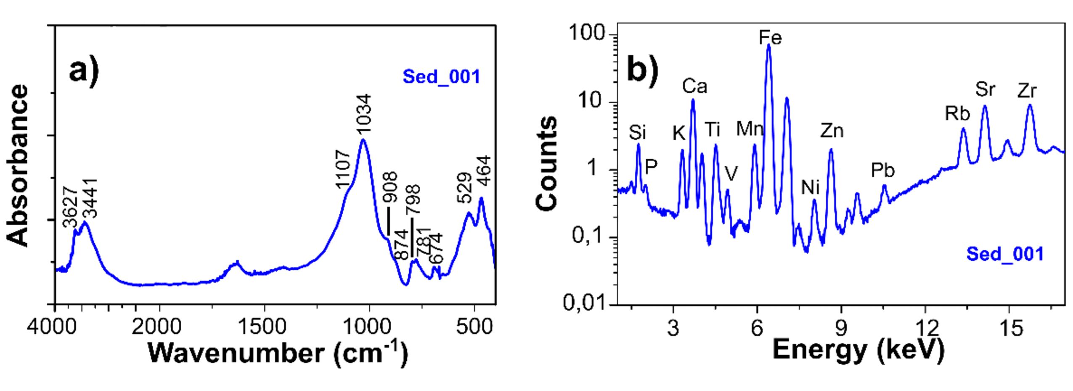
Figure S1. (a) Vibrational response and (b) elemental composition of the sedimentary material Sed_001 from sample FACEN-Pvert0002.

Table S1. Vibrational responses of the sedimentary material Sed_001 from sample FACEN-Pvert0002.
FT-IR response Sed_001
Wavenumber (cm⁻¹) | Assignation | References
464 | Si-O-Si asymmetrical bending  Allophane | 1,2
529 | Si-O-Al stretching | 3,4
674 | Si-O symmetrical vending  Si-O-Al stretching | 3,4
781 | Si-O symmetrical stretching | 2–4
798 | Si-O symmetrical stretching | 2–5
874 | CO₃ | 6–8
908 | Al(OH) | 4,9
1031 | Al(OH)₃  Si–O–Si | 2,10,11
1107 | Si–O–Si or CO₃ | 2,3,5,7
3441 | –OH | 4,9,12,13
3627 | –OH | 4,9,12,13

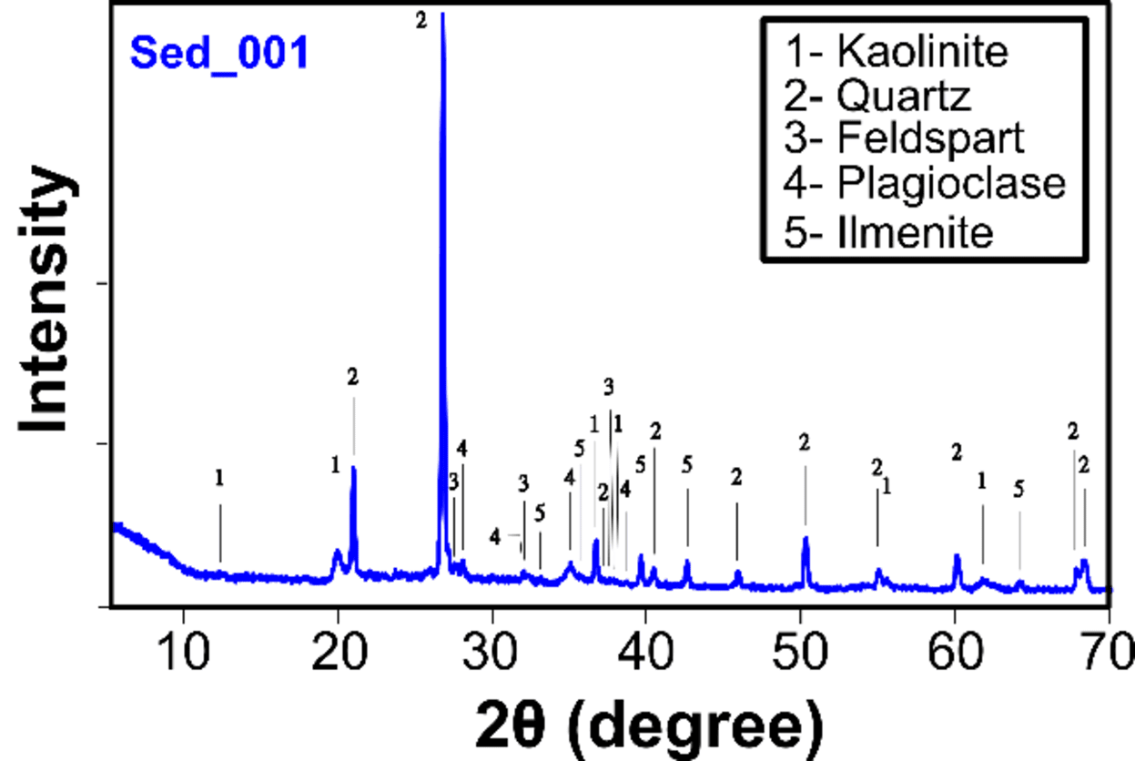
Figure S2. X-ray diffraction pattern of sedimentary material Sed_001 from sample FACEN-Pvert0002, indicating the identified crystalline phases.

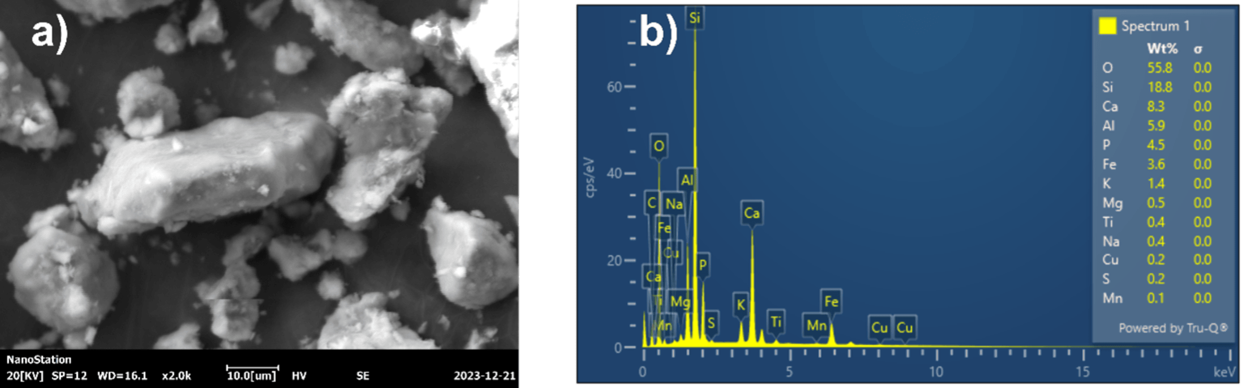
Figure S3. SEM- EDS image of Sed_001.

References
1. J. Hlavay, K. Jonas, S. Elek, J. Inczedy. "Characterization of the Particle Size and the Crystallinity of Certain Minerals by Infrared Spectrophotometry and Other Instrumental Methods. I. Investigations on Clay Minerals". Clays Clay Miner. 1977. 25: 451–456. 10.1346/CCMN.1977.0250611
2. P. Singh, S. Sharma. "Thermal and Spectroscopic Characterization of Archeological Pottery from Ambari”. Assam. J. Archaeol. Sci. Reports. 2016. 5: 557–563. 10.1016/j.jasrep.2016.01.002
3. G. Anbalagan, A.R. Prabakaran, S. Gunasekaran. "Spectroscopic Characterization of Indian Standard Sand". J. Appl. Spectrosc. 2010. 77(1): 86–94. 10.1007/s10812-010-9297-5
4. P.S. Nayak, B.K. Singh. "Instrumental Characterization of Clay by XRF, XRD and FT-IR". Bull Mater Sci. 2007. 30(3): 235–238. 10.1007/s12034-007-0042-5
5. H. Khemis Medini, M. Arbi. "Chemical and Physical Analysis of Sandstone and Relationship with Weathering Damage of Madâin Sâlih Monuments". 2018. 12(1): 37–45. 10.1080/16583655.2018.1451113
6. M.M. Beasley, E.J. Bartelink, L. Taylor, R.M. Miller. "Comparison of Transmission FT-IR, ATR, and DRIFT Spectra: Implications For Assessment of Bone Bioapatite Diagenesis". J. Archaeol. Sci. 2014. 46: 16–22. 10.1016/j.jas.2014.03.008
7. J.H. Jerez-Jaimes, S.E. García-Gómez, L.E. Cruz-Guevara. "¿Hueso Fósil O Simple Roca? Espectroscopia FT-IR Y Criterios Para La Identificación De Estructuras Óseas Fosilizadas". Bol. Geol. 2012. 34(1): 67–80.
8. A. Brangule, K.A. Gross. "Importance of FT-IR Spectra Deconvolution For the Analysis of Amorphous Calcium Phosphates". In: IOP Conference Series: Materials Science and Engineering. Riga, Latvia; 29 September–2 October 2014. P. 12027. 10.1088/1757-899X/77/1/012027
9. J. Zhang, J. Xiao, S. Li, W. Ran. "Manure Amendment Increases the Content of Nanomineral Allophane in an Acid Arable Soil". Sci. Rep. 2017. 7(1): 1–8. 10.1038/s41598-017-14445-2
10. F. Iyoda, S. Hayashi, S. Arakawa, B. John, et al. "Synthesis and Adsorption Characteristics of Hollow Spherical Allophane Nano-Particles". Appl. Clay Sci. 2012. 56: 77–83. 10.1016/j.clay.2011.11.025
11. J.D. Schuttlefield, D. Cox, V.H. Grassian. "An Investigation of Water Uptake On Clays Minerals Using ATR‐FT-IR Spectroscopy Coupled with Quartz Crystal Microbalance Measurements". J. Geophys. Res. Atmos. 2007. 112(D21). 10.1029/2007JD008973
12. T. Wan, X. Wang, Y. Yuan, W. He. "Preparation of A Kaolinite-Poly(Acrylic Acid Acrylamide) Water Superabsorbent by Photopolymerization". J. Appl. Polym. Sci. 2006. 102(3): 2875–2881. 10.1002/app.24729
13. F.B. Reig, J.V.G. Adelantado, M.C.M.M. Moreno. "FT-IR Quantitative Analysis of Calcium Carbonate (Calcite) and Silica (Quartz) Mixtures Using the Constant Ratio Method. Application to Geological Samples". Talanta. 2002. 58(4): 811–821. 10.1016/S0039-9140(02)00372-7

