Subgenomic RNA abundance relative to total viral RNA among SARS-CoV-2 variants

Supplemental Material

Maxwell Su, Phuong-Vi Nguyen, Sara Ping, Alejandra Rojas, Laila Hussaini, Ludy Registre Carmola, Azmain Taz, Julie Sullivan, Greg S. Martin, Anne Piantadosi, Magaly Martinez, Wilbur A. Lam, Evan J. Anderson, Jesse J. Waggoner
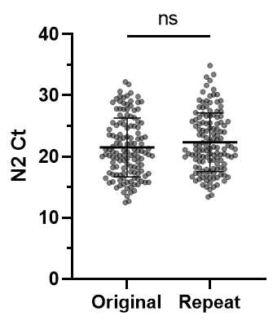
Supplemental Figure 1. Original and repeat N2 Ct values from 132 samples with sufficient material for retesting in the N2RP assay. Original and retest Ct values did not differ significantly (mean Ct difference, 0.85 cycles; p=0.2, t test).

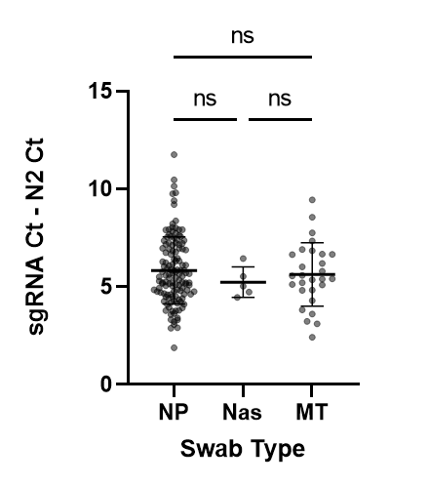
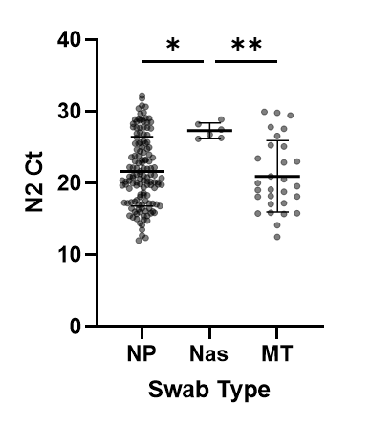
A
B
Supplemental Figure 2. A) Distribution of N2 Cts by swab type. Anterior nasal swabs (Nas) had significantly higher Cts than NP (p=0.014) or MT (p=0.010) swabs. B) The relative abundance of sgRNA, calculated as the difference between sgRNA and N2 Ct, was not significantly different based on swab type (p ≥ 0.4 for all comparisons).

Supplemental Figure 3. Linear regression of A) N2 Ct and B) abundance of sgRNA versus day of illness at sample collection.
A
B

A
B
Supplemental Figure 4. The distribution of A) N2 Ct values and B) relative abundance of sgRNA among vaccinated (n=34, Vac.) and unvaccinated (n=134, Unvac.) participants for whom data was available. Results did not differ significantly between the two groups (p ≥ 0.8 for both comparisons).
Supplemental Table 1. Genomic and subgenomic RNA of SARS-CoV-2 variants as defined by specific mutations detected in the Spike SNP assay.
Spike SNP Mutations | Variant | n | N2 Ctª | sgRNA detected, n (%) | sgRNA Ctª | sgRNA – N2 Ctª
None (K417 only) | Ancestral | 31 | 21.8 ± 4.2 | 30 (96.8%) | 27.9 ± 5.3 | 5.0 ± 1.6
501Y | Alpha | 22 | 22.8 ± 5.3 | 22 (100%) | 30.7 ± 7.4 | 7.9 ± 3.4
417var, 484K, 501Y | Beta | 12 | 26.8 ± 4.2 | 10 (83.3%) | 31.6 ± 4.1 | 5.9 ± 1.4
417var, 484K, 501Y | Gamma | 30 | 18.4 ± 4.0 | 30 (100%) | 24.4 ± 4.6 | 5.5 ± 1.1
484K | Zeta (P.2) | 14 | 21.4 ± 5.0 | 14 (100%) | 27.6 ± 6.3 | 5.9 ± 1.8
452R, 478K | Delta | 31 | 23.1 ± 4.0 | 31 (100%) | 28.8 ± 4.1 | 6.1 ± 1.8
478K, 501Y | Omicron | 29 | 21.0 ± 5.0 | 28 (96.6%) | 28.6 ± 6.0 | 5.6 ± 1.6
Abbreviations: Ct, cycle threshold; N2, SARS-CoV-2 nucleocapsid rRT-PCR target
ª Information presented as mean ± SD.

Supplemental Table 2. Results of least squares multivariable regression analysis of sgRNA Ct values based on N2 Ct value and variant.
Variable | Estimate | 95% CI | P value
Intercept | 1.18 | -2.22 - 4.58 | 0.49
N2 Ct | 1.24 | 1.08 - 1.39 | <0.001
Alpha: N2 Ct | 0.04 | -0.17 - 0.26 | 0.68
Beta: N2 Ct | -0.31 | -0.63 - 0.02 | 0.06
Delta: N2 Ct | -0.32 | -0.54 - -0.10 | 0.005
Gamma: N2 Ct | -0.13 | -0.35 - 0.09 | 0.26
Omicron: N2 Ct | -0.01 | -0.22 - 0.20 | 0.93
P2: N2 Ct | -0.01 | -0.25 - 0.24 | 0.94
Degrees of freedom, 151; R² = 0.91

