Supporting information
Figure S1. Distribution of Xenodon with a rounded rostral scale in South America and their relations with the Ecoregions, adapted from (Dinerstein et al., 2017). White cross X. severus, black cross X. werneri and black diamond X. rabdocephalus.
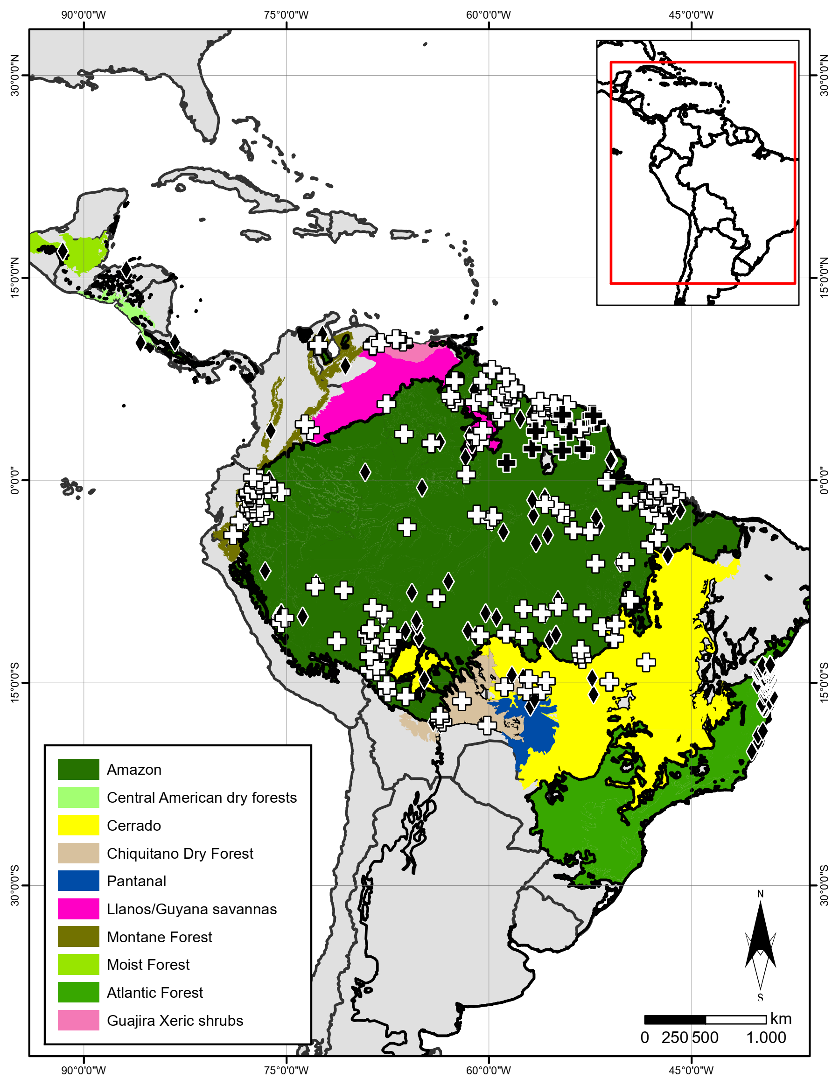

Figure S2. Distribution of Xenodon with a rounded rostral scale in South America and their relations with the Ecoregions, adapted from (Dinerstein et al., 2017). Black star X. merremii.
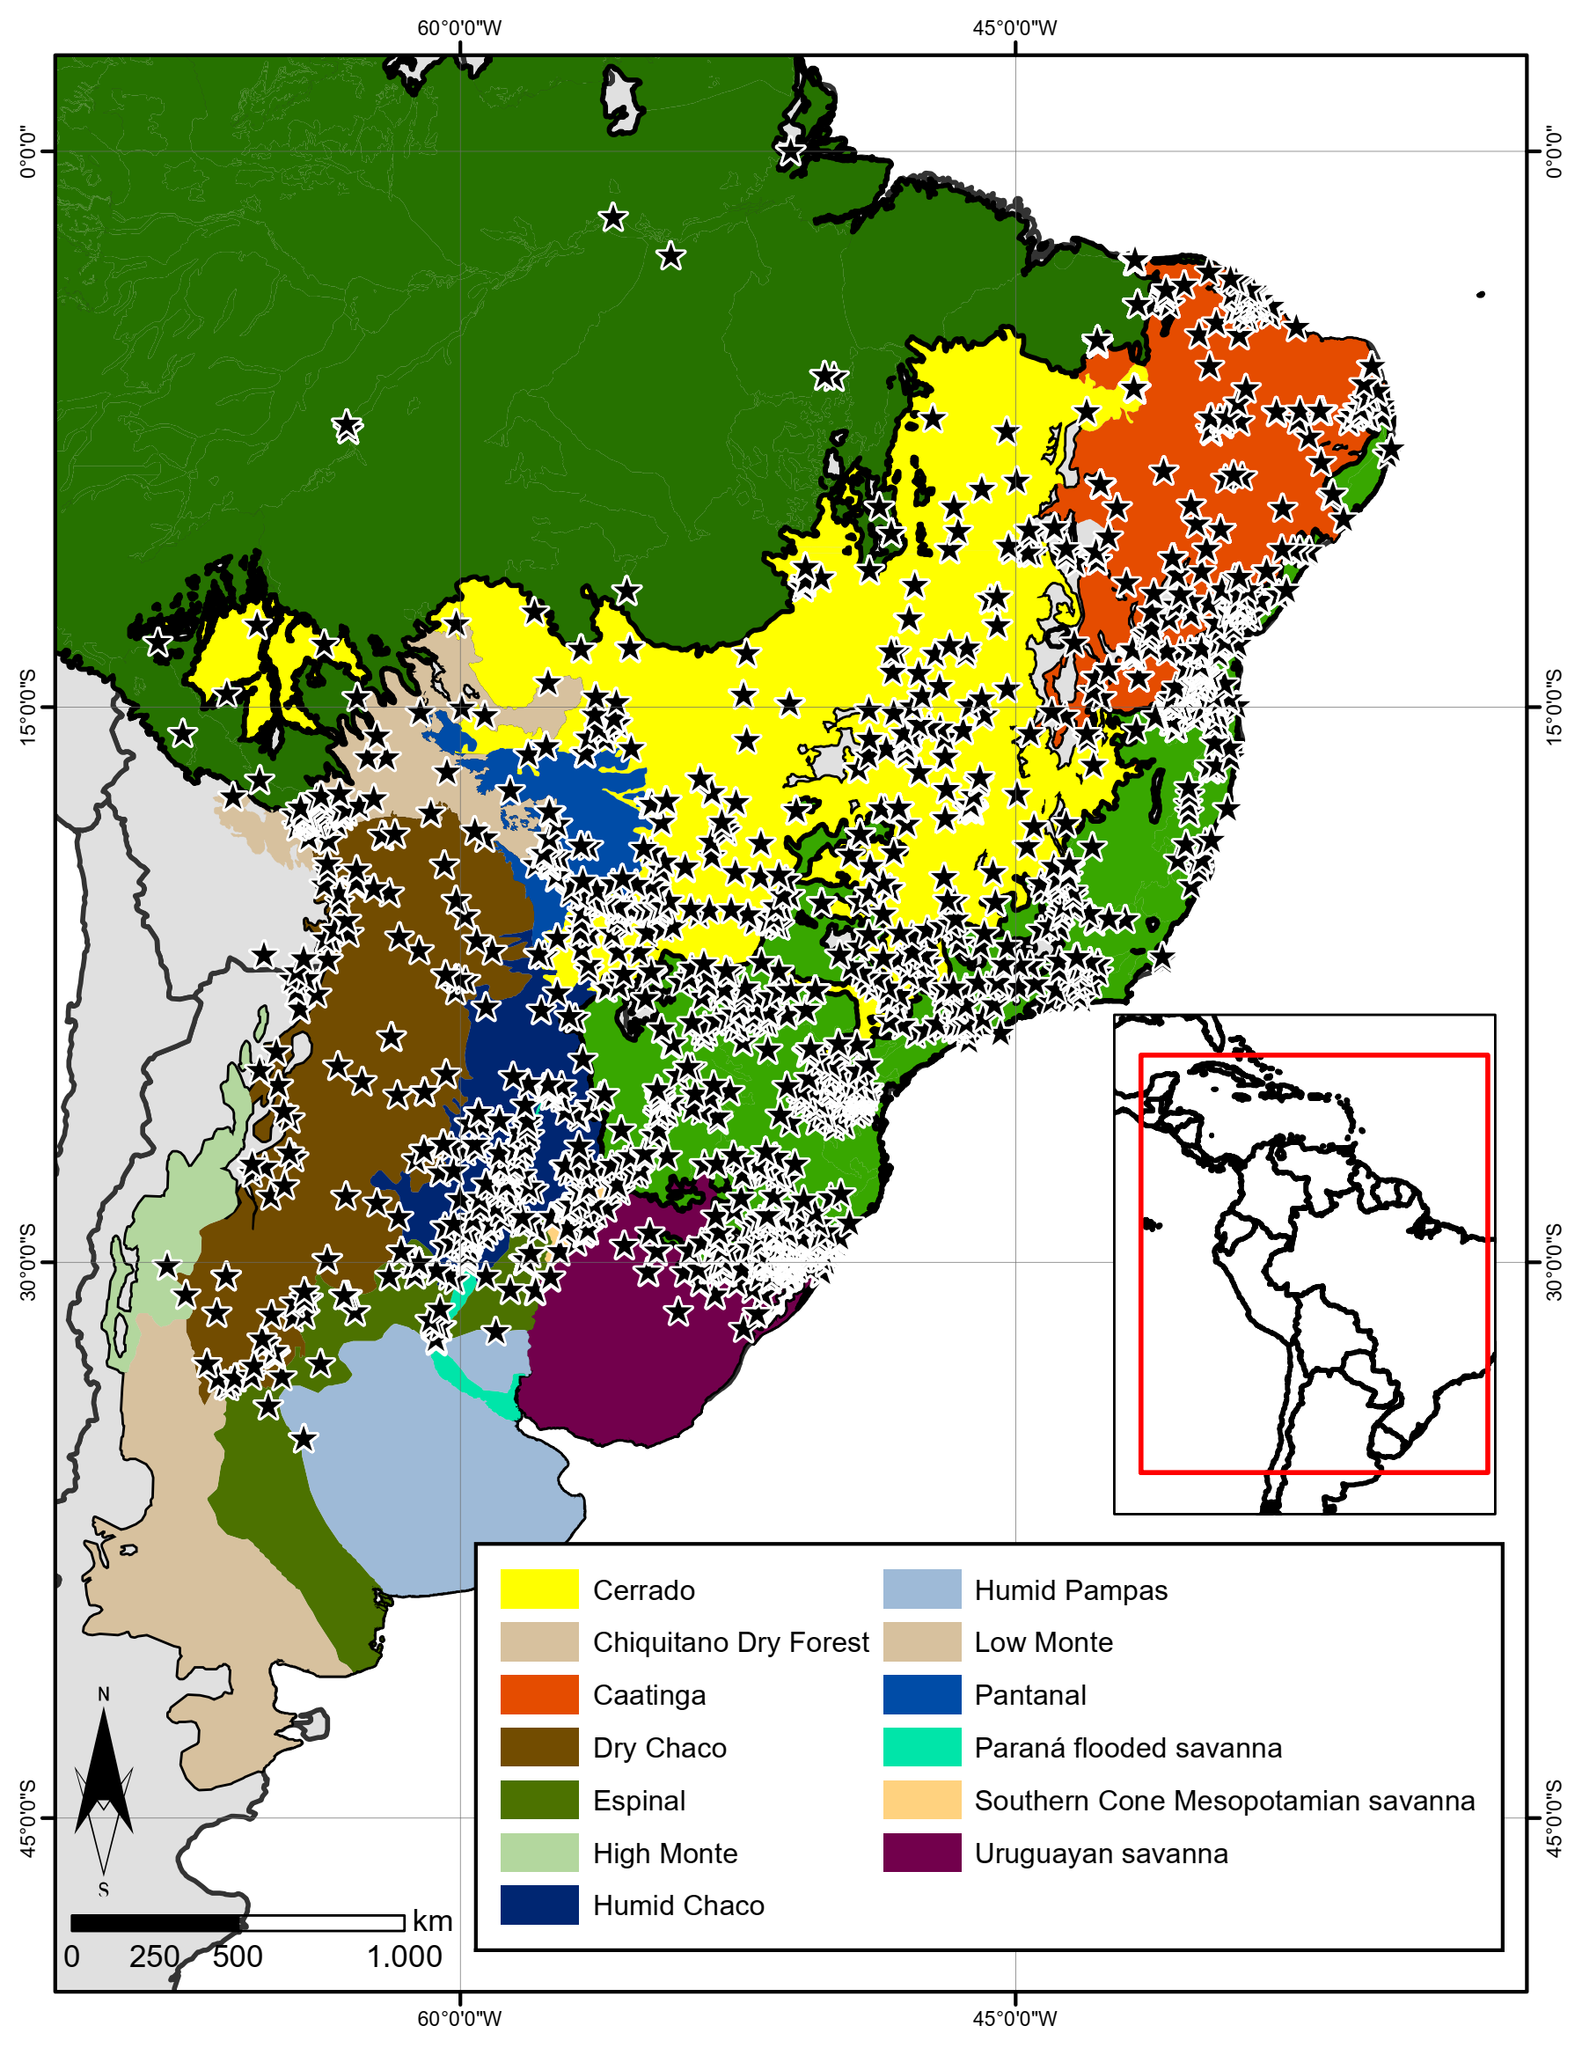

Figure S3. Distribution of Xenodon with a rounded rostral scale in South America and their relations with the Ecoregions, adapted from (Dinerstein et al., 2017). black triangle X neuwiedii, white circle X. guentheri.
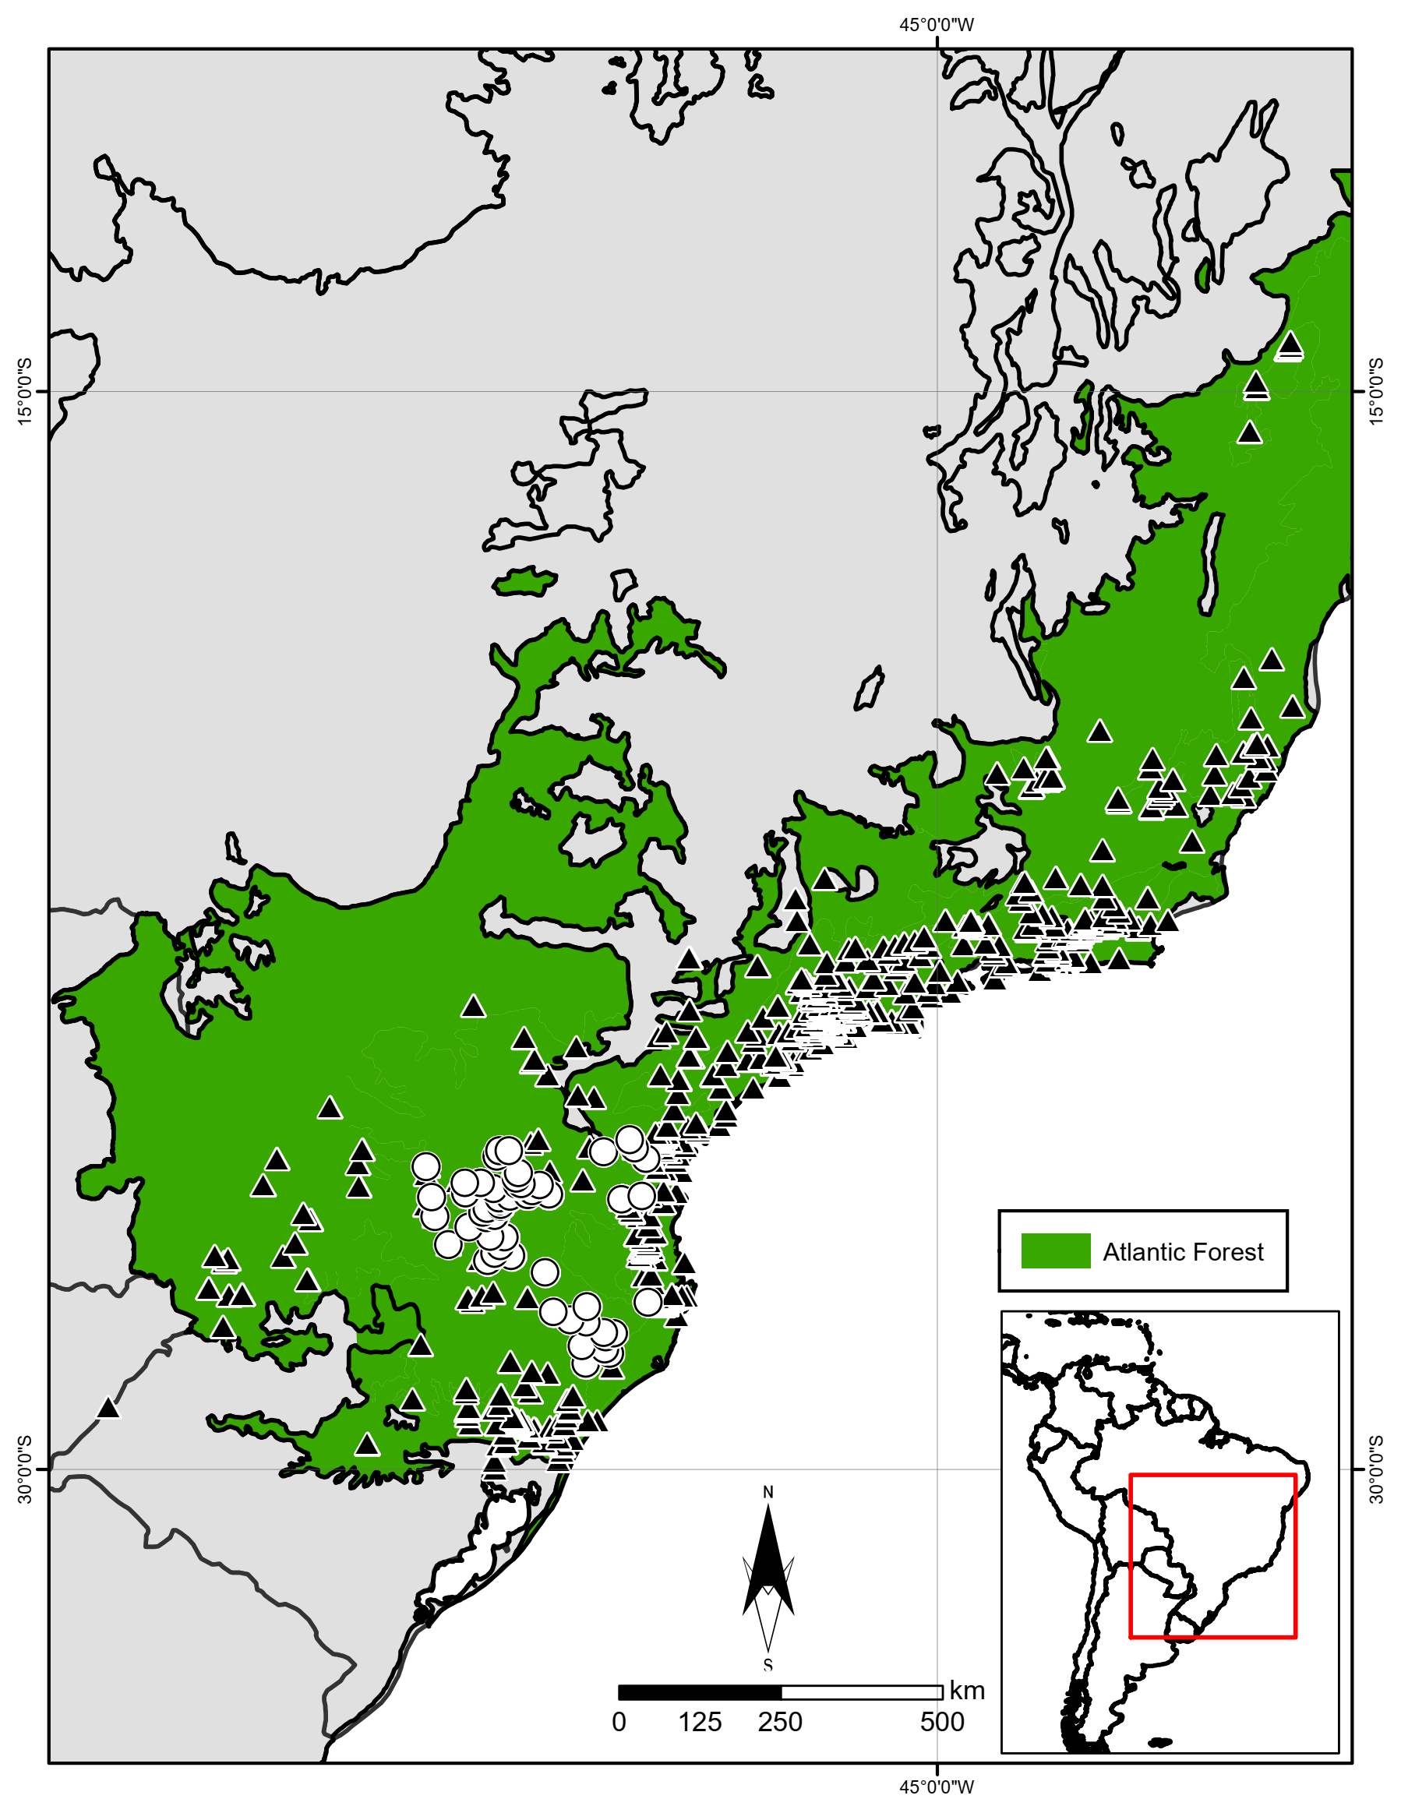

Figure S4. Distribution of Xenodon with keeled rostral scale in South America and his their relations with the Ecoregions, adapted from (Dinerstein et al., 2017). white triangle X. nattereri, white circle X. histricus, black triangle X. matogrossensis, black square X. pulcher, white square X. semicinctus, and black circle X. dorbignyi.
